




Jack Pennington
2299****
Cracking Wi-Fi Security Methods: Are SMEs Protected?
MSc Research & Development Project Report

Computer Security and Networks
Department of Computing
Supervisor: *************
2018/19

Abstract
The research has been conducted to demonstrate the vulnerabilities of Wi-Fi security and to examine how SMEs are at risk, as a result of inadequate technical knowhow and limited finances to implement better security methods; the evidence does suggest that SMEs are to be the first affected. The research methods employed throughout will be literature review, simulated Wi-Fi penetration test and also a questionnaire for SMEs. Due to the research being commenced for SMEs the findings from the research will be used to create a best practise Wi-Fi security guide, the guide will be used to assist SMEs to better securing their wireless network. To enforce the need for the research, new attack vectors against WPA2 have been discovered in 2018. This being said statistic from (Symantec Corporation, 2017) reveals that the most common cybercrime experienced in 2017 is 42% of Home Wi-Fi has been broken into, this statistics relevance can be questioned; the results obtained from this study reveal that 100% of SMEs use standard home versions of Wi-Fi security. Findings from the overall study reveal the thesis to be successful, to prove that SMEs Wi-Fi does prove to be vulnerable. The findings reveal that as a result of Wi-Fi having inherent security flaws, SMEs having inadequate Wi-Fi security practises as displayed throughout the SMEs questionnaire and evidence from Wi-Fi penetration test. As mentioned previously the findings above will be correlated and combined to create a best practise guide to assist SMEs to overcome the vulnerabilities discovered.

Contents
Acronyms 2
Abstract 3
Acknowledgements 3
Dedications 3
List of Tables 5
List of Figures 5
1. Introduction 6
1.1 Motivation 6
1.2 Thesis structure 7
1.3 Aims – To highlight the importance of using the most secure security method for Wi-Fi within SMEs 7
2. Literature review 8
2.1 Introduction 8
2.2 Wired Equivalent Privacy 8
2.3 WI-FI Protected Access 9
2.4 WI-FI Protected Access Two PSK 11
2.5 WI-FI Protected Access Three SAE 13
2.6 Issues affecting SMEs Wi-Fi security 15
3. Methodology 16
3.1 Methods used throughout research 16
3.2 Justification of methods 18
3.2 Methods Rejected 20
3.3 Ethics 21
3.4 Penetration Testing Methodology 21
3.5 Penetration Testing Plan 22
3.6 Reconnaissance 22
3.7 Vulnerability Assessments 22
3.8 Exploitation 22
3.9 Reporting 23
4.Implementation 23
4.1 WEP Reconnaissance 23
4.2 WEP Exploitation 24
4.3 WPA Reconnaissance 26
4.4 WPA Exploitation 27
4.5 WPA2 Reconnaissance 31
4.6 WPA2 Exploitation 31
4.6 Implementation Analysis 35
5. Data Gathered 37
5.1 Analysis 37
6. Findings 46
7. Recommendations 48
8. Conclusion 49
8.1 Future research 49
References 50
Appendices 52
Wi-Fi Security Best Practice Guide 54

List of Tables
Table 1 Research objectives and methods 5
Table 2 Attacks WPA3 mitigates (Kohlios & Hayajneh, 2018) 12
Table 3 SMEs Questionnare 15
Table 4 Attacks used against Wi-Fi security standards 20

List of Figures
Figure 1 elliptic curve cryptography 12
Figure 2 elliptic curve cryptography example (Yeh & Tien-Ho, 2011) 13
Figure 3 penetration testing methodology 20
Figure 4 enable wireless card in Linux 22
Figure 5 starting airodump-ng 23
Figure 6 scanning target network 23
Figure 7 using besside-ng to launch attack 24
Figure 8 initialization vector brute force 24
Figure 9 successful exploitation 25
Figure 10 Connection attempt 25
Figure 11 Scanning WPA wireless network 26
Figure 12 using Airodump-ng to capture four-way handshake 27
Figure 13 successful capture of handshake 27
Figure 14 using aireplay-ng to send de-authentication frames to target 27
Figure 15 sending de-authentication frames 28
Figure 16 password file used to exploit four-way handshake 28
Figure 17 using Aircrack-ng to brute force four-way handshake 29
Figure 18 successful four-way handshake exploitation 29
Figure 19 attempting to connect to target network 29
Figure 20 successful network connection 30
Figure 21 network scan 30
Figure 22 using hcxdumptool to retrieve PMKID 31
Figure 23 using hcxpcaptool to write captured PMKID to hashcat format 32
Figure 24 starting hashcat to crack target network PMKID 32
Figure 25 password file used to exploit PMKID 33
Figure 26 successful network exploitation 33
Figure 27 retrieved password entered 33
Figure 28 authentication successful 34
Figure 29 attack time comparison 35
Figure 30 expression 35
Figure 31 Question 1 36
Figure 32 Question 2 37
Figure 33 Question 3 38
Figure 34 Question 4 38
Figure 35 Question 5 39
Figure 36 Question 6 40
Figure 37 Question 7 41
Figure 38 Question 8 42
Figure 39 Question 9 43
Figure 40 Question 10 44

Introduction
The motivation for this research is due to the heavily relied upon Wireless Networks and the security flaws that are present, for example, using USB antennas hackers can be positioned physically off-site allowing for attacks to take place at any time. According to (Barnes & Bautts, 2002) SMEs rely heavily on Wi-Fi to perform business critical tasks, they predict by 2010 the majority of fortune 2000 organisations will have deployed wireless local area networks; Due to the age of the book you can assume this prediction did intern come true because of the popularity of wireless networks today. The increased usage and popularity of Wireless Networks suggests that the thesis needs to be answered, to analyse if current encryption protocols are adequate to ensure the security of SMEs wireless networks. The research conducted will include a simulated Wi-Fi attack to attempt to crack the Wi-Fi standards pre-shared key, this will allow an attacker to infiltrate a SMEs WLAN. The research will analyse if current methods are enough to ensure security, also the research will review the current academic literature and provide a discussion of the newly created encryption protocol WPA3. The findings from the research will be used to create a best practice guide for securing wireless networks for SMEs.

1.1 Motivation
Since its creation Wi-Fi has been criticised for not being secure, due to its wireless nature; this is due to the encryption protocols used to ensure security from point A the wireless router to point B the wireless enabled device. This inherit security flaw occurs in all WI-FI security standards such as Wireless Equivalent Privacy (WEP), Wi-Fi Protected Access (WPA) and Wi-Fi Protected Access 2 (WPA2); According to (Sari & Karay, 2015) “the key size of the WEP standard is only 40-bit key. This makes WEP open to attack especially the brute force attack.” Additionally, a security researcher named as Mathy Vanhoef has discovered a weakness in the security protocol WPA2. Referring to (The Guardian, 2017) the article states that “The security protocol used to protect the vast majority of Wi-Fi connections has been broken”. The findings above prove to be the motivation to commence the research that will follow. If the findings appear to be correct, then SMEs would be left vulnerable to exploitation and eavesdropping. Due to small businesses not having the capital or the knowhow to implement more sophisticated security mechanisms, this leaves them vulnerable to exploitation.

1.2 Thesis structure
The thesis structure will consist of 8 chapters, chapter 1 introduces the study and identifies the aims. This chapter also specifies the objectives of the research in table 1 and how it will be achieved, also the relevant background information as to justify the need for the study Is provided throughout chapter 1. Chapter 2 provides the literature review of relevant journals; this analysis provides background of relevant Wi-Fi security mechanisms and their present security vulnerabilities. With the addition of analysed literature as to why SMEs have inadequate Wi-Fi security practises. Chapter 3 provides a breakdown of the methodology used throughout the research, this section comes complete with methods used throughout and their justification for use also methods that been rejected and the rationale for the rejection. Chapter 4 show the implementation of the simulated Wi-Fi attacks against WEP,WPA and WPA2. The section provides figures to illustrate the penetration process and to also displays the outcomes from the attacks with figure annotations. Chapter 5 reveals data gathered from the SMEs questionnaire, the section also includes analysis of SMEs responses correlated to other questions to give explanations for results. Chapter 6 presents findings from the overall research to provide answers to the research thesis, this has been achieved by using triangulation methods to examine and provide anaylsed from the literature analysed, SMEs questionnaire and the simulated Wi-Fi penetration test. Chapter 8 provides a breakdown of the overall research conclusion by reinitiating the research thesis, detailing the aims and objectives of the study to then conclude by stating how the aims and objectives have been achieved and to answer the research thesis. This chapter will also include the future direction of the research.

1.3 Aims – To highlight the importance of using the most secure security method for Wi-Fi within SMEs

Table 1 Research objectives and methods
Objectives | Methods
1.To Analyse Past and present Security methods for Wi-Fi, presenting vulnerabilities and mitigation methods. | Literature Review
2.To understand the factors why SMEs are not adequately prepared for Wi-Fi security risks. | Literature Review
3.To provide SMEs with a questionnaire to establish which security method they use for their Wi-Fi Connection. | Questionnaire
4.To show vulnerabilities with current Wi-Fi  security methods. | Simulated Attack
5.To create a best practice guide to securing WI-FI for SMEs. | Questionnaire and Simulated attack

2. Literature review

2.1 Introduction
The following literature review will analyse the past and present Wi-Fi security protocols to assist in providing a better understanding on how SMEs are potentially protecting their Wi-Fi. The first standard to be reviewed from the 802.11 Wi-Fi family will be Wired Equivalent Privacy. The analysis will include why the Wired Equivalent Privacy standard should not be used by small business and the reasons behind why the security standard is so insecure, the same approach will be taken to analyse the next security protocol Wi-Fi Protected Access and the analysis will detail why the standard needed to be updated to create Wi-Fi protected access two. The literature review will also detail the latest standard of protection Wi-Fi protected access three a comparison shall be made against WPA2 and also why SMEs should upgrade their equipment to support the new standard to improve security.

2.2 Wired Equivalent Privacy
Wired Equivalent Privacy also known as WEP is a security protocol that was introduced to secure wireless networks during 1997 (Aneja & Sodhi, 2016), the security protocol was the first cryptographic security mechanism created. The idea behind WEP is that the protocol encrypts wireless traffic to ensure privacy and integrity also the protocol aimed to be as private as a wired network connection. (Malgaonkar & Patil, 2017)
To ensure security WEP uses the Rivest Cipher4 stream cipher algorithm also known as RC4, the security algorithm was created by Ron Rivest. The algorithm was created for the RSA data security in the year 1987; the algorithm was also used to secure SSL and also TLS. The reason the algorithm was so popular was due to how easy it is to implement its speed and efficiency (Paul & Maitra, 2012). The WEP protocol uses shared-key authentication to allow users to connect to an access point based upon question and answers procedure between computer and access point, this mechanism also only uses symmetrical key with pseudo sequence. Basically, this means the same key generated is used for both encryption and decryption this makes WEP seriously vulnerable to brute force attacks due to WEPs lack of key management, the key never changes allowing an attacker to brute force the key for a long period of time. According to (Aneja & Sodhi, 2016) “In 2001 several weaknesses were identified. Now WEP connections can be cracked within minutes”. These results are similar to those reported by (Malgaonkar & Patil, 2017) stating that “recent brute force attacks on wireless local networks are jeopardizing privacy. This means that WEP protocol is sensitive to attacks no matter the key length”. In comparison from both journal articles it is conclusive that wired equivalent privacy should not be used to secure wireless networks. Both journals agree that the weakness present in the RC4 cipher hinders WEPs security mechanism, as mentioned above there are many weaknesses present. The main one being the use of static keys being recycled and used multiple times allowing an attacker to intercept initialization vectors and attempt to retrieve the key from the interception. Also mentioned is the weakness against brute force attacks this allows an attacker to generate their own initialization vectors, due to no reply detection the attacker can run this initialization vector till the correct key is generated thus revealing the correct WEP key to then allow attackers access to the vulnerable wireless local area network.
The only option to mitigate the vulnerabilities present in WEP is to upgrade the security standard to use WPA, previous research has established that the only method to attempt to add extra security to WEP according to (Rittinghouse & Ransome, 2004) is to upgrade to TKIP. The TKIP protocol was developed to combat the majority of vulnerabilities that WEP has the author states “WEP does not support per-packet authentication resulting in a vulnerability”. To mitigate this issue the author recommends using the message integrity check, this protocol stops the attacker from not only changing packets in transit from point A to point B but also stops the packet from being edited due to the integrity check. According to (Vacca, 2006) to assist in the security of WEP other security methods can be used in conjunction with WEP, this security mechanism is MAC address filtering. This security method would only allow MAC addresses verified by the access point to connect to the network, the only issue with this method is that attackers can exploit MAC address spoofing. This allows attackers to instantly change their MAC address. Most studies in the field of securing WEP have only focused on the upgrading to using the TKIP protocol, it is assumed this is due to the age of the protocol. As a result of the complications with upgrading to TKIP and implementing message integrity check it would be easier for SMEs to implement WPA.

2.3 WI-FI Protected Access
Due to the security vulnerabilities that exist in WEP, a new standard was created to mitigate these risks. The standard is called WI-FI Protected Access also known as WPA; as mentioned above the weaknesses in WEP are due to the RC4 cipher. Wi-Fi protected access fixes this issue by using the temporal key integrity protocol also known as TKIP. Previous research has established that the only improvement that has been made to WEP is the implementation of this new protocol. According to (Malgaonkar & Patil, 2017) “RC4 is an encryption device implemented in hardware of wireless network adapters and is not replaceable. To solve this problem TKIP uses RC4 devices in the way that changes the methods of use of the shared key”. The above quotation reveals that the RC4 cipher is still used in WPA but when it is used with the TKIP protocol it becomes more secure. (Sari & Karay, 2015) elaborates that TKIP is used by WPA for data encryption, the protocol does this by eliminating the use of the symmetric key encryption that is used in WEP. The protocol generates a different key randomly for every packet, also the 128-bit key that is generated and used to encrypt data. This upgrade also mitigates the attempt to brute force initialization vectors due to WPA not allowing replays, due to the implementation of a sequence counter. The author also states that TKIP is combined with MIC also known as message integrity check this protocol combined with TKIP ensures that packets of data cannot be modified. This was a main weakness in WEP allowing attackers to modify messages because of the checksum.
To date, several studies have investigated the security vulnerabilities that exist in WPA. (Waliullah & Rahman, 2015) states that one big security flaw within WPA is the reuse of the RC4 cipher, the reuse of this encryption cipher does leave security holes in WPA thus making the standard vulnerable to offline dictionary and brute force attacks against the 4-way handshake protocol. This finding is consistent with that of (Sari & Karay, 2015) that also details similar findings throughout his research with some slight deviation. The journal states that WPA is not only vulnerable against brute force attacks, the standard is also susceptible to a denial of service attack that allows attackers to broadcast de-authentication packets to disconnect hosts from access points. This attack method is also detailed by (Wang & Wang, 2016) the attack method uses DOS attack to disconnect hosts from its access point, the attacker will wait to capture a four-way WPA handshake packet using freely available tools. Once authentication packets have been captured this allows the attacker to brute force the captured packets thus revealing the PSK passcode. To genuinely make this attack work the attacker will need to use a password file of over 5,000 most common used WPA passwords in order to exploit the authentication process.
The four-way handshake exists within WPA to establish a connection between access point and the user, once a pairwise master key also known as PMK is agreed upon the authenticator begins a four-way handshake. This method is used to allow a host to connect to the access point without revealing the pre-shared key. As the name suggests many journal articles also concur that there are four stages of the four-way handshake.
Opening the transmission, the access point sends its random number to the mobile device in cryptography this is also called Nonce. When the mobile device receives the randomly generated number everything is present for the device to generate the pairwise transient key. This is what takes place in message one. Message two occurs by the mobile device generating its own random number, according to (Buttyan & Dora, 2007) this message also includes a message integrity code also known as MIC. This is used to stop attackers using man in the middle attacks to spoof and edit the message while in transit. The MIC is then processed by the mobile device using the key-integrity key, this has just previously been derived from the pairwise master key. Once this message has been received the access point has everything it needs derived from the PMK, now the access point processes the PTK and uses key-integrity key to authenticate if the MIC is correct. If so the access point believes the mobile device possesses the PMK. Message three allows the access point to send a message containing a message integrity code to the mobile device. The MIC is processed using the key-integrity key of the PTK. This part of the message contains the foundation value of an array of numbers that will be used to identify data packets, this is used to identify replay attacks that WEP could not identify. This message also notifies the access point that the mobile device has installed the keys and is ready for encryption. Message four entails that the mobile device authenticates the third message this authentication means the mobile device is ready for encrypting all data transferred from access point to mobile device.
As discussed above vulnerabilities in WI-FI protected access are found in the four-way handshake protocol, this allows hackers to DOS unsuspecting users and also to intercept the handshake thus giving attackers enough information to brute force the pre-shared key. From researched commenced by (Lashkari & Danesh, 2009) state that to mitigate the issue implementing strong pre-shared key passwords would at least slow down the brute force attack process. The previous paragraph details the process of the four-way handshake protocol, the vulnerability that is present in WPA is Denial of Service (DoS), this attack is valid due to no message one authentication when the random number is sent to initiate the handshake. (Vanhoef & Piessens, 2017) details how the attack is possible, due to message one not being encrypted it can be abused by injecting a plain text message one to the mobile device even after the handshake has been established. The access point can then decide at any moment to refresh the pairwise key. By starting a new four-way handshake this then refuses the mobile device network access thus stopping the connection due to message one not being authenticated. These results are similar to those reported by (Jafri & Ho, 2009), both authors detail the exploit existing in the four-way handshake protocol. To mitigating the exploit the author created a concept idea that could be implemented but was not. The author details implementing the same message integrity code into the unencrypted message one, this would stop attackers from spoofing the message one thus not allowing a DoS attack to take place because when the spoofed random number reaches the access point it is dropped due to not possessing the pairwise master key.

2.4 WI-FI Protected Access Two PSK
The vulnerabilities within WPA have the possibility of being severe towards SMEs, which has created demand for a new standard to be created to protect WLAN, this standard is called Wi-Fi Protected Access 2 (WPA2). According to (Lashkari & Danesh, 2009) WPA was only released because of the vulnerabilities in WEP to only be the interim solution to security issues. The author continues to state that WPA2 has been designed to be the future-proof solution due to lessons learned from the implementation of WEP. The differences present in WPA from WPA2 are the encryption algorithm that is used to secure data transmissions, the standard also includes an enhanced integrity check this is similar to the message integrity protocol that exists in WPA (Sellers, 2016). WPA2 uses advanced encryption standard (AES) to better protect wireless devices against hacking this standard replaced the TKIP protocol, it was created in January 1997 by NIST to replace the widely used standard Data Encryption Standard (DES) (Dobbertin & Rijmen, 2004).
The AES encryption standard has been combined with the Cipher-Block Chaining Message Authentication Code Protocol (CCMP), the standard was created to replace TKIP and WPA. The protocol is complete with many added extras, referring to (Kohlios & Hayajneh, 2018) research the author details that CCMP provides WPA2 with different security mechanisms. For example, CCMP is derived from Counter Mode (CTR) with Cipher-Block Chaining (CBC) the author details that CTR is used for data confidentiality and CBC is used for authentication and integrity. The encryption takes place within the four-way handshake similar to WPA but with added security and message integrity checks and higher encryption bits. The Pairwise Transient Key (PTK) is generated and passed through an AES encryption algorithm, this added security benefit provides WPA2 with 128-256 keys in sequences of 32 bits due to AES being a block cipher. Comparing all three standards this increase in encryption size does prove to make the security standard much more effective. When WEP was created it only uses a 40-bit shared key then the upgrade to WPA used 128-bit now the most commonly used WPA2 stand has increased to use 128 – 256 bits.
The latest security vulnerability that has been discovered in WPA2 was discovered in 2017 by Vanhoef and Piessens, the attack is named Key Reinstallation Attack (KRACK). The attack exploits vulnerabilities in the four-way handshake protocol of WPA2 allowing attackers to decrypt, replay and possible forge frames (Vanhoef & Piessens, 2018). The attack is initiated by a genuine client attempting to gain access to the network, the access point generates the Secret Pairwise Master Key (PMK) this key is generated for the session to allow the four-way handshake to begin. The access point then generates two more keys the Pairwise Transient Key (PTK) and the Group Temporal Key (GTK), the KRACK attack exploits message three of the four-way handshake when the GTK is installed WPA2 does not take dropped or interrupted connections into consideration. WPA2 allows message three to be resent, this enables an attacker to intercept traffic that is encrypted from legitimate users. To reset the WPA2 encryption keys the hacker can resend message three to the access point and a nonce request allowing for encryption keys to be reset, resulting in data sent over the network will be encrypted with the same key. This allows attackers to gradually decrypt all data until the whole key is decrypted resulting in the network no longer being secure (Shapiro, 2017). From the literature analysed it appears that some inconsistencies exist around this attack (Kohlios & Hayajneh, 2018) states “This applies only to the TKIP GCMP encryption schemes however. It has been shown that this cannot work with CCMP, which WPA2-PSK uses”. Also, other research details that the four-way handshake exploit what KRACK uses is entirely based on the correct conditions being met, for example, the exploit is only viable on the Linux operating system and the Android platform (Shapiro, 2017). Whereas the KRACK attack webpage does detail that most modern Wi-Fi routers will most likely be affected by some variant of the attack (Vanhoef, 2017).
Another attack method has been discovered against the security protocol WPA2, the attack was discovered by researcher Jens atom Steube in August of 2018. The vulnerability was discovered when attempting to discover exploits in the latest Wi-Fi security standard WPA3 (Ramirez & Abelardo, 2019). Previous studies of the PMKID attack have not provided in-depth discussion of how the attack works, the only source of information available is a hashcat forum. This is because the researcher who discovered the attack also created the password cracking tool known as hashcat, both journal articles examined referenced the forum no other literature exists about this attack mainly because the attack has only recently been discovered. The attack vector discussed above allows attackers to view the PSK in hash format allowing the hacker to perform off-line dictionary attacks on the Wi-Fi network. This attack does prove to be more devastating than other attacks discussed because attackers do not need to wait for a legitimate user to reconnect or interfere with the four-way handshake protocol. The attack according to (Kohlios & Hayajneh, 2018) exploits the Robust Security Network (RSN) information element, the attacker receives an EAPOL frame upon the authentication phase before the four-way handshake. Using packet capturing tools like Wireshark allows attackers to examine the Pairwise Master Identification Key (PMKID) thus revealing the PSK in hash value. The PKMID is generated using information already available to the attacker such as PMK name, MAC address of the AP and the MAC address of the device attempting to authenticate. The attacker can then compute the candidate PSKs computed from the word list of passwords and check the PMKID against the PMKID sent in the initial EAPOL frame. If the values match the password attempt is correct and the PSK has been recovered.
One attack that is present in WPA2 that was not mitigated surprisingly is de-authentication attack, this attack was also present in WPA. This vulnerability is the starting point for most attack when attempting to intercept an authentication packet via the four-way handshake. The attack is viable because of the lack of protection of management frames that are transferred from client to access point, the attack Is viable due to the same weakness that was presented in WPA. The attack uses MAC address spoofing to initially sit between the client and the access point, the attacker sends de-authentication frames to the access point or client. Once the client or access point has received the de-authentication frame the connection is immediately dropped. This is due to the de-authentication frame being part of management frames rather than encrypted frames that are transferred (Kohlios & Hayajneh, 2018).
The security vulnerabilities that are present in WPA2 that have been discussed in detail above do prove to have some mitigation processes, the Wi-Fi alliance website does state updating WPA2 PSK to use WPA2 Protected Management Frames (PMF) does mitigate many attacks due to the attack that is mitigated is used in a variety of other attacks. The attack is de-authentication, normally in WPA2 the management frames that are sent from client to access point have no protection this allows hackers to disconnect legitimate users to then capture reconnection frames. The Wi-Fi alliance webpage does not detail how the management frame is protected, it only states that is it using technology used in WPA3. The best way to mitigate all attacks mentioned above is to simply update equipment or implement WPA3, the Wi-Fi alliance webpage does state they have released patches to mitigate risks from Krack attack. The article also referred to the Common Vulnerabilities and Exposures (CVE) webpage to show what vulnerabilities have been patched through updating hardware (WIFI Alliance, Security Update October 2017). Both (WIFI Alliance, Security Update October 2017) and (Feher & Sandor, 2018) share a number of key features, these features are encouraging users to update to the latest security standard WPA3 because of the vulnerabilities that it mitigates. For example, (Kohlios & Hayajneh, 2018) research details the methods how WPA3 mitigates certain attacks. Using WPA3 stops de-authentication frames, the author states “When an access point receives an unencrypted de-authentication frame from a client who is already in session, the access point will trigger the SA mechanism and return an error response for the client to try again later given a certain comeback time. The AP will then send an encrypted SA query request to the client and await the SA query response within the response time. The adversary would not be able to send back an encrypted response without the encryption key. Therefore, performing a de-authentication attack is unfeasible”. The study has identified that WPA2 has indeed shown some recent security vulnerabilities in the year 2018, it would be recommended to SMEs to upgrade to the latest version of the standard to avoid being the victim of a data breech. WPA3 does appear to solve every recently discovered vulnerability that reveals the network pre-shared key.

2.5 WI-FI Protected Access Three SAE
The latest security protocol to be released and certified by the Wi-Fi alliance is Wireless Protected Access Three (WPA3) released in 2018, this protocol was designed to surpass the security vulnerabilities of its predecessor WPA2. The protocol does this by replacing PSK with password-based Simultaneous Authentication of Equals (SAE), this protocol was also used to secure wireless mesh networks in the year 2000. The protocol was then deemed not secure referring to (Kohlios & Hayajneh, 2018) research that states the protocol was vulnerable to passive and active attacks, which it claimed to protect against. The research also suggests after some revision of the standard in 2015 the protocol has proved to provide the protection it promised.
The SAE protocol provides WPA3 with mitigation from previous attacks such as offline password cracking and the PMKID attack, the protocol does this by using different key exchange methods such as dragonfly key exchange and elliptic curve cryptography. This means when the handshake between client and access point takes place the key exchange performs a password-authentication key exchange using zero knowledge proof, basically each side client and access point prove they know the password without revealing any password-derived data. This latest security update proves to render the majority of attacks useless against WPA3 (Hewlett Packard Enterprise Company, 2018).
WPA3 uses elliptic curve cryptography to provide encryption to data that is transferred from access point to client, elliptic curve encryption works in a similar way to transport layer security (TLS). The encryption uses public key cryptography, this means when keys are generated one is kept within the access point and the public key is transferred to the connecting client using the dragonfly protocol for key exchanges. The elliptic curve is used in the key exchange to generate keys using large prime numbers instead of the actual password.


Figure 1 Elliptic Curve Cryptography
$$y^{2}={(x}^{3}+ax+b)$$
Figure 2 Elliptic Curve Cryptography example (Yeh & Tien-Ho, 2011)

Figure 1 represents an example of Elliptic Curve Cryptography; the encryption is used to generate a public and private key to be used to encrypt data. Figure 2 represents the equation. The security mechanism within Elliptic Curve Cryptography (ECC) relies heavily on its trapdoor function, the trapdoor function allows keys to be generated easily but when the key is reverse engineered it is difficult to return to the original prime numbers used (Kohlios & Hayajneh, 2018). The public key is derived from the integers used to plot the graph, the private key is derived from the hops it takes from A,B and C even if the attacker knows the equation for the curve it proves difficult to reverse engineer to decipher the equation to figure out how many hops from the integers was taken. Due to the curve being symmetric on the X axis this proves to make the encryption even more difficult to decipher (Wagnon, 2016).
When the ECC parameters have been selected, the dragonfly four-way handshake takes over to establish communication from access point to client. The dragonfly handshake begins by establishing that both parties agree to an ECC parameter and to a large prime number, the access point and client share the same password P. Next both parties derive X coordinate from the established password P then the password is combined with a hash function H and a key creation function known as the KDF. This step is repeated until X has become a quadratic, this is used to generate keys by using ECC. The results of the quadratic then generated keys for both parties known as PE password element, then access point and client generate two random numbers. Once the two random numbers are generated they are combined to create the scalar and element, this is then exchanged to check if the hash function is correct thus confirming both parties have the same hash (Humboldt University Informatics, 2018).
The security mechanisms discussed above do prove in concept to render most WPA2 vulnerabilities none applicable for WPA3, referring to previous research from (Kohlios & Hayajneh, 2018) the authors propose scenarios when attackers would attempt existing attacks on WPA3 and how this security standard mitigates the attacks. Case 1 highlights how the standard is not vulnerable to de-authentication attacks, in WPA2 the attacker could send a de-authentication frame to the access point and then spoof its own MAC address. The de-authentication frame sent to the access point disconnects the client because the frame is a management frame that is not encrypted. The mitigation within WPA3 to combat this attack is encrypted management frames, when an access point receives de-authentication requests that are not encrypted the access point responds with an encrypted management frame. The attacker cannot respond with an encrypted response without knowledge of encryption keys. The mitigation for this attack has existed for a number of years, according to (Arana, 2006) the solution for this attack vector is implementing encrypted management frames and being able to identify spoofed packets, this journal was written in 2006 but the mitigation for this attack has only been made available in the creation of WPA3 in 2018 (WIFI Alliance, Security Update October 2017).
Other attacks discussed by (Kohlios & Hayajneh, 2018) also prove to have been mitigated, the PMKID attack mentioned in the WPA2 section, allows attacker to exploit the PMKID. This attack allows the PMKID to be displayed as a hash thus allowing attackers to attempt to brute force the key thus revealing the PSK. WPA3 mitigates this attack by not having a static PMK that is not derived from its PSK, the attacker would have to interact with the dragonfly handshake.
Table 2 Attacks WPA3 mitigates (Kohlios & Hayajneh, 2018)
Attack | Mitigated by WPA3
De-authentication | Yes
Handshake Capture Dictionary Attack | Yes
PMKID Hash Dictionary Attack | Yes
Rouge Access Point | Partially
Evil Twin Attack | No
Handshake Capture EN/Decryption | Yes
KRACK Exploit | Yes
ARP Spoofing | Partially
SSL Stripping | No
DNS Spoofing | No

Table 2 provides details of attacks that have been mitigated by WPA3, the clear choice to mitigate the security risks of WPA2 for SMEs would be to upgrade to WPA3. The upgrade does not necessarily always happen thus leaving SMEs vulnerable when using technology. Statics from the UK government details that over four in ten businesses 43% experienced a cyber security breach or attack in the last 12 months (Department for Digital, Culture, Media & Sport, 2018). With statistics like these it is important for SMEs to prioritise excellent cyber security practises, most common reasons SMEs do not update hardware and software is mainly because of the expense of the technology security mechanism and the knowhow the SMEs have could be limited.

2.6 Issues affecting SMEs Wi-Fi security
SMEs all over the UK rely on information technology to perform daily tasks such as emails, business operation and point of sale tills. These systems are used to provide small businesses with the equipment needed to facilitate daily functions. Serval reports have shown strong consistencies between (watad & Wahah, 2018) and (HM Government, 2015) studies in the literature. Both authors reports do come to an agreement that many small businesses place cyber security threat among one of their highest risks and the severity of impact to the business. The disadvantages to becoming so dependent on IT are its accompanying risks to business when attempting to secure information and prevent hacking attack. Statistics from (HM Government, 2015) found that 22% of small businesses admit they do not know where to start with cyber security. This statistic is due to the challenges SMEs face, existing research by (watad & Wahah, 2018) details that the cause behind this statistic is due to the lack of in-house knowhow and intricacy of implementing technology.
Other issues include a lack of training for staff and also management culture. Referring to (Dojkovski & Lichtenstein, 2010) research findings show that managers play important roles when shaping cyber security culture, if the manager of a SME has poor cyber security then employees will also follow poor security practises. Lack of cyber security policies and procedures also effects SMEs, one main cause of SMEs displaying poor information security practices is implementation of hardware. Referring to (Armin, 2014) poor hardware configuration leads to security exploits. For example, all hardware used by SMEs has a default password set by the manufacturer (Armin, 2014) states “The users have to change the default setting to something secretive. If users have poor understanding of computer system, some settings stay default”. SMEs not correctly implementing hardware correctly does pose huge cyber security risk, (Armin, 2014) findings confirm that 62% of breaches are caused due to poor configuration of technology. Research from (Meijer & Lorente, 2015) details that the severity of weak default WPA2 passwords in user’s routers does require immediate response, the author also continues to criticize Wi-Fi users stating that passwords created by individuals that are not technically minded could produce even worse passwords.

3. Methodology

3.1 Methods used throughout research
The thesis of this research is to establish as the title suggests are SMEs protected against Wi-Fi exploitation, due to the discovery of new attack methods against the most commonly used security mechanism WPA2. Due to SMEs not having adequate technical skills this leaves them vulnerable to exploitation and data theft, this not only puts the SMEs at risk it also puts their customers data at risk.
This study makes use of both quantitative and qualitative research methods making the study a mixed methods investigation, this method has been selected because of the benefits it provides throughout the analysis phase allowing both data types to be analysed together. Mixed methods research is defined by (Onwuegbuzie & Johnson, 2004) “The class of research where the researcher mixes or combines quantitative and qualitative research techniques, methods, approaches, concepts or language into a single study”. One of the methods to be used throughout the research is a literature review, to analyse existing subject matter and to establish what security vulnerabilities already exist. How the attack will affect SMEs and the possibility of mitigating these attacks to ensure a higher level of security, the literature analysed also assists the creation of the SMEs questionnaire to retrieving secondary data.
Other data collection methods that have been employed throughout this study is a quantitative questionnaire, the questionnaire details such questions as “Has the Wi-Fi password been kept the same since its setup (default password)”. These questions are to be asked to establish if SMEs are responsible for this present weakness in wireless networks and also to assist in the creation of objective 5 to create a best practise guide to assist SMEs to secure their wireless network. The sampling selection for the quantitative questionnaire was stratified sampling, this method was selected because the questionnaire requires SMEs to fill in the questionnaire to establish secondary data. SMEs are defined as small to medium-sized enterprises that are independent firms which employ less than 250 employees. The SMEs have been selected using the conditions that the firms have less than 30 employees and are an independent business. Other sampling methods would not have suited the questionnaire due to its nature, yes participants that are not employed by SMEs could have been selected to complete the questionnaire, but this would have resulted in questionnaire results that are not valid towards the thesis. The questionnaire shall be sent out using email, this allows the data to be captured within the SMEs working environment. This lets participant fill out the questionnaire in their own time, to also keep validity this method grants that technical details of equipment can be checked before or during the questionnaire.
Table 3 SMEs Questionnaire
Questionnaire Questions | Responses | Rational for Question
Does your business use Wi-Fi | Yes/No | This question was asked to establish if the SME uses Wi-Fi, if the response is no the questionnaire ends as there is no need for the participant to continue.
How many Wi-Fi networks does your business have. E.g., guest network and business network? | 1 Network  2 Networks  3 Networks  4 Networks + | The rationale behind this question was to establish how many wireless networks SMEs have.
How do you connect to your Wi-Fi network in your business? | Password  Username and Password  No Password | This question was asked to establish how the SME connects to their network, username and password response is used to establish if the SME uses enterprise versions of Wi-Fi security. The assumption has been made within the study that, the size of the SMEs will not have Radius servers to authenticate due to the size of the business. This is the reasoning why the analysed literature does not discuss enterprise versions of Wi-Fi security.
Does everyone in your business use the same password to connect to your Wi-Fi? | Yes/No | This question is used to establish if every SME uses pre-shared key (PSK) to authenticate.
Has the Wi-Fi password been kept the same since its setup? (Default Password) | YES  No  Do not know | This question is used to establish if SMEs follow standard security practises.
Do you have onsite technical support or a system administrator within your business? | Yes  No  Telephone Only | To establish if the SME has technical support to assist in Wi-Fi security and implementation.
How often do you change your Wi-Fi password? | 1 to 2 weeks  2 to 4 weeks  1 to 2 months  2 to 6 months  6 months to 1 year  Once every year  Never | To find out if SMEs follow basic cyber security practises. To understand what makes theirs networks vulnerable to certain types of attack.
How long is your Wi-Fi password in your business? | Less than 6 characters  6 to 12 characters  Greater than 12 characters  No Password | To establish Wi-Fi password practises within SMEs, most default passwords are 6 to 12 characters.
How regularly does your routers software get updated? | Every 2 months  Every 4 months  Once every year  Never gets updated  Do not know | The question is used to establish if SMEs are vulnerable to new recently discovered Wi-Fi attacks (KRACK).
What security does your Wi-Fi use? | WEP  WPA  WPA2  Do not know | To discover if SMEs are using outdated security solutions to secure wireless networks.
The methods used to capture primary data using qualitative and quantitative methods through the use of a simulated penetration test against an assessment wireless network, this simulation is done to establish that the vulnerabilities found in objective 1 are genuinely a threat to the security of SMEs. Due to the nature of the simulated attack or even experiment the data retrieved will be in qualitative and quantitative format allowing for a better analysis of result from the simulation. The simulation will be conducted using strict conditions using virtual machines and genuine hardware, all the hardware will be kept at default settings to ensure the validity of the simulation. As a result of the nature of the simulated attack using penetration testing tools does pose some significant ethical issues, this is why the penetration test will be commenced under strict conditions only permitting that the tools will only be used against the simulation test hardware to not conflict with any ethical issues.

3.2 Justification of methods
The design of this research employs a mixed methods design, the underlying thesis investigates the question are SMEs wireless networks secure due to the recent discovery of new attack vectors. Due to the nature of the study it is best to use a mixed methods approach because of the benefits it provides; these benefits are a better accuracy of findings. Rather than using a quantitative questionnaire on its own that only establishes the configuration of Wi-Fi security within SMEs; solely using a questionnaire to acquire data would only show, that SMEs do not change the default password; using mixed methods to use a qualitative simulation verifies the risks of leaving this password as default. The attacks that have been used throughout the penetration test take advantage of this weakness. This provides the likelihood of accurate results through triangulation methods.
Triangulation methods in research is defined by (Heale & Forbes, 2013) as the practice of “using more than one approach to researching a question. The objective is to increase confidence in the findings through the confirmation of a proposition using two or more independent measures”. The design of this research employs the use of triangulation methods by using mixed methods, this is done by analysing literature within the subject matter. By also retrieving questionnaire data to establish how SMEs secure their Wi-Fi networks. Also, to use a simulated attack to capture qualitative and quantitative data to understand if the attacks are a security risk to SMEs due to their Wi-Fi configuration. This method shall be used to analyse captured primary and secondary data, triangulation is used to provide better analysis of results thus allowing for cross validation of data. The only issue presented from using mixed methods research is the time it takes to gather primary and secondary data.
The research utilizes the use of a quantitative questionnaire to question SMEs, this has been used to establish how SMEs have configured their wireless networks. The justification to use this method is for the purpose of the time it takes to create a questionnaire and send it out to the SMEs; this method provided a huge benefit to the research. This method was chosen due to its time saving qualities and low cost. The questionnaire will be sent to SMEs using email, this also benefitted the research by allowing the SMEs to confirm their configuration settings while in the working environment. The questionnaire also allowed large amounts of quantitative data to be collected at one time, the only criticism present within this method is the limited details that can be retrieved. Although in the case of the research using a questionnaire was more appropriate than using interviews, this is due to the time-consuming nature of interviews and also the validity of results retrieved from interviews is questionable when interviewing about technical details of Wi-Fi configuration. For example, it is assumed the majority of interview candidates will not know their Wi-Fi configuration. questionnaires allow the candidate to check the configuration before responding, thusly grating more valid data retrieval from the questionnaire rather than interviews.
The qualitative method used throughout the research is defined as an experiment, the experiment conducted is a simulated penetration test against a Wi-Fi network. It is commonly known that experiments in research normally produce quantitative results. As a result of the configuration the penetration test will retrieve both quantitative and qualitative. The simulated Wi-Fi attack method was used within the research to identify relationships between questionnaire results and findings from the attack. Most researchers investigating experiments have utilised the relationships between findings, referring to (Blaxter & Hughes, 2010) the author states “The experiment is the only research design which can, in principle, yield causal relationships”. The use of the penetration test also assists the analysis of data by using triangulation methods to identify relationships between the questionnaire and simulated attack. The benefits of performing a simulated attack allows the validity of results to be confirmed by other researchers performing the same experiment and arriving at the same results, this method also allowed attack vectors discussed throughout the literature review to be utilised in a simulated setting to show how they function. The nature of the research requires an experiment to be used were a variable can be manipulated rather than observed, performing an observation against Wi-Fi security would not return useful information for the studies underlying thesis.

3.2 Methods Rejected
The research conducted utilizes certain research methods, the used techniques provide the research with more suitable responses and outputs than the other methods. The methods used throughout are literature review, SMEs questionnaire and penetration tests. The use of these methods has been justified above; the methods that have been rejected from the research are interviews, observations, surveys and focus groups. The underlying rational for not using interviews it due to the nature of the research thesis, interviews take much more time to complete and validity of answers is questionable when querying none technical individuals in a given time frame. This type of questioning could put the selected individual under pressure to give an answer that is not correct. In the interest of maintaining anonymity for the individuals and complying with the ethical standpoint of the study, face to face interviews have been rejected due to this breech of ethics were the individuals can be identified (Blaxter & Hughes, 2010). A number of studies have begun to examine the disadvantages of using interviews. For example, (Adams, 2015) suggests that to interview an individual they may need to be knowledgeable about the subject matter. This proves to be a disadvantage of using face to face interviews, whereas using a questionnaire enables the researcher to capture more valid results as the questionnaire can be sent to a knowledgeable employee within the SME.
Considering the requirements of the research using an observation would not have been useful to answering the underlying thesis. Since the observation method could not provide any useful results, Wi-Fi security mechanisms cannot simply be observed. The researcher could have perhaps watched a SME installing a wireless router, but this method would only show that SMEs have inadequate security practises were the default password does not get changed. To date, several studies have investigated the use of observations within research. With reference to (Blaxter & Hughes, 2010) and (Denscombe, 2017), both authors acknowledge the disadvantages of using this method. Their rational for this is that observation may yield unrealistic results due to the nature of the observation. This could be due to the observing party being visible thus resulting in the observation not being in a natural setting.
For the purposes of the research it was more appropriate to use a questionnaire rather than a survey, surveys can be delivered in many forms such as online surveys, telephone surveys and face to face survey. Surveys are also known to allow the respondent to fill out their own thoughts and feeling, whereas questionnaires are a set of predefined questions only allowing users to respond with predefined responses to keep validity. The main criticism from the analysed literature does conclude that issues with surveys are lack of response rate could affect your research (Blaxter & Hughes, 2010). Other literature on the disadvantages of surveys does relate to the previous point stated, (Floyd & Fowler, 2014) argues that a drawback of surveys come from failure to collect answers from everyone selected. This issue when using surveys does indeed present potential source of bias and then the validity of the research can be questioned.
As a result of the underlying thesis of the study focus groups are not used due to the nature of the technical questioning. For example, questioning individuals in a group setting could force participants to respond with incorrect results due to lack of knowledge on the subject. To solve this issue using correct sampling methods could solve the issue, because of the type of thesis researching SMEs Wi-Fi security using focus groups may result in participants not being able to attend due to lack of staffing and no other employees to operate the business. Whereas using a questionnaire allows the SME to fill out the questionnaire in their own time.

3.3 Ethics
The research conducted throughout the paper employed the use of a questionnaire and a Wi-Fi simulated attack, research ethics have been considered throughout the study. As a result of the nature of the research the SMEs questionnaire has kept all respondent SMEs strictly anonymous throughout the questionnaire, the SMEs also have the option to retract the data inputted to the questionnaire by 28/04/2019. The simulated Wi-Fi attack was also ethically considered, as a result of the attack being simulated against the test wireless network no permissions to exploit the network were needed. As can be gathered from the implementation phase the tools used to exploit the wireless network have only been used against the test wireless network, to ensure no other wireless networks were exploited the use of predefined targeting files have been used throughout the penetration test using the test networks MAC address. Consideration have also been met to cater for the Computer Misuse act 1990, it can be confirmed no legislation was broken throughout the simulated Wi-Fi penetration tests (Uk Legislation, 2019).

3.4 Penetration Testing Methodology
For the purposes of the simulated Wi-Fi attack a scenario was devised to make the simulated attack follow real conditions of a genuine SME, throughout the test the wireless router was placed roughly 14 meters away from the attacking machine. As previously mentioned this was done to completely simulate a realistic penetration test against a SME. To keep the simulated attack fair and to keep validity of results all default router settings such as default password and broadcast channel used will remain as default. The only variable changed will be the security settings of the router to provide a full array of penetration testing attacks to display that SMEs using outdated security solutions are at risk.

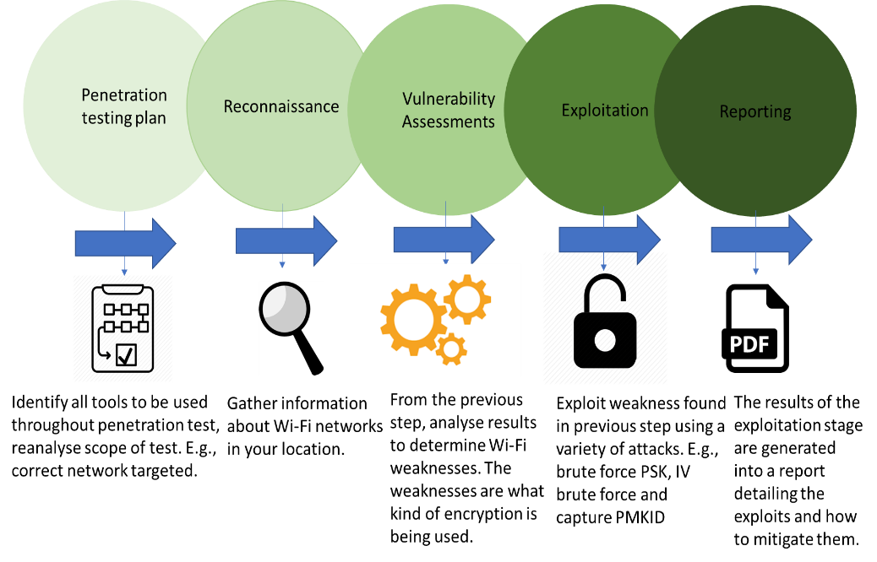

Figure 3 penetration testing methodology

3.5 Penetration Testing Plan
For the purposes of the penetration test a scenario scope has been created to suit the needs of the realism of the simulated attack, the scope of the assessment will be received from the client employing the penetration tester. The scope in this scenario will include details like the location of the penetration test, the scenario location will be the Edge Hill University. Due to ethical issues the SME will be anonymous, the scope then details the penetration tester should only operate 14 meters away from the SME building to simulate a realistic attack. The scope also details the MAC address of the router to exploit, no other routers or access points are identified so this limits the attack to only one router. Considering the nature of the penetration test the tools highlighted to be used are all wireless exploitation tools such as Airodump-ng, Aireplay-ng, Aircrack-ng and Besside-ng. The design of the penetration test will follow an aggressive approach rather than passive, this is done to place the simulated SMEs equipment under the stresses of a real-life attack. Once the scope has been established the penetration tester needs to establish the effort estimation, for scenario purposes the estimated time of the penetration test will be a week day assuming most SMEs do not open on a weekend and the opening hours established will be 9:00am to 17:00 so the attack will take place between opening hours. The depth of the attack will only attempt to penetrate Wi-Fi security mechanisms using an array of attacks highlighted in the literature review section, once the Wi-Fi security mechanisms have been exploited the attack will end as the scope details only to exploit Wi-Fi security.

3.6 Reconnaissance
Since the penetration test is a simulated attack it is assumed for the purposes of the attack that the scope has already identified a target Wi-Fi network, although using Airodump-ng allowed the target network to be scanned like in a real-life scenario. The scan revealed details of the target wireless network, the details it revealed was items like the access points MAC address, broadcast channel and the encryption used. The information retrieved will be carried over to the next section to highlight what vulnerabilities are present within the target network.

3.7 Vulnerability Assessments
Commencing with the information gathered from the reconnaissance section this allowed vulnerabilities within the SME’s wireless network to be analysed to establish what vulnerabilities can be exploited. The vulnerabilities found were the encryption used by the SME. For example, it was found that the simulated SME was using WEP security. This allowed the correct tools to be identified to exploit the vulnerability. The tools used were Airodump-ng and Besside-ng. For the validity of the scenario all wireless security mechanisms were changed to suit the needs of the simulated attack.

3.8 Exploitation
Continuing from the section above once vulnerabilities are discovered they can be exploited, the attacks used have been mentioned throughout the literature review. The attacks used to exploit each security mechanism used by the SME. Table 4 provides details of what attacks have been used for each security configuration.
Table 4 Attacks used against Wi-Fi security standards
Security Configuration | Attacked used to exploit
WEP | Initialization Vector Brute Force
WPA | Four-way handshake Offline Brute Force
WPA2 | PMKID Offline Brute Force

3.9 Reporting
This section of the penetration test methodology will provide the SME with a description of the vulnerabilities discovered, the impact the exploit will have on the business and what devices are affected such as laptops tablets or even equipment. The vulnerability type will be explained to distinguish if the exploit is hardware, software or configuration error. The report will also provide workarounds to allow the SME to continue business operations then the report assists SME in mitigation the exploit by providing fixes. These fixes could be simply as updating software or enforcing strong password policies and procedures. In this scenario the report will provide details on how to mitigate the risks from brute force attacks, the mitigation as mentioned above will be not to use outdated security configuration and to regularly update Wi-Fi passwords.

4.Implementation
To perform the penetration test against the scenario SME certain equipment will be required, this equipment is one laptop to perform the penetration test and an external USB antenna. The antenna used is brand TP-LINK model number TL-WN722N, due to configuration issues with the virtual machine the wireless card used within the laptop is not supported in Linux. For the attack a wireless router is required, the router was selected because of its support of all security configurations. The brand is again TP-LINK and model Archer VR900. To host the virtual machine Oracle VM VirtualBox version 5.2.26 was used, the Kali Linux distribution used was 64-bit architecture and the 2019 updated version of Linux. For the purpose of the scenario and ethical issues the wireless router was not connected to the internet, this was due to the nature of the penetration test and an internet connect is not required.
The following section will introduce the simulated attack against the scenario SME, the attack is performed to achieve objective 4 to show vulnerabilities with current Wi-Fi security methods. The attacks used have been mentioned throughout the literature review and methodology section. Table 4 also details the attacks used to exploit the wireless security mechanism.

4.1 WEP Reconnaissance
The reconnaissance section of the penetration test requires the penetration tester to scan the target network, to establish information that can be used to perform an attack. The information gathered from the scan is the wireless networks BSSID, channel used, encryption used, cipher and ESSID. Due to this attack being simulated the target has already been identified as network TP-LINK_116B, for the purposes of the scenario the security of the network has been changed to WEP.
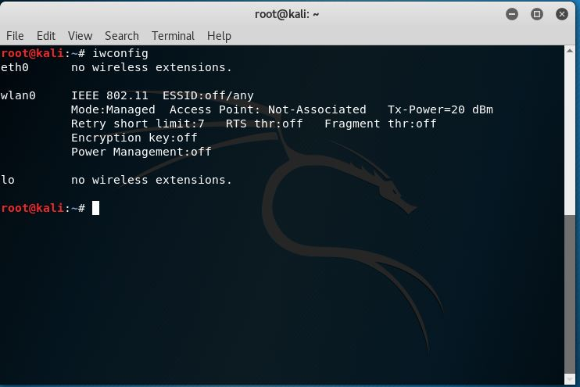
Figure 4 displays that the wireless card used has been found in Linux, this is achieved by typing “iwconfig”.
Figure 4 enable wireless card in Linux
Figure 5 was used to start Airodump, Airodump is the application used to scan wireless networks. Wlan0mon is the wireless card used to do the scan, notice mon at the end this means the scanning interface is currently in monitor mode.
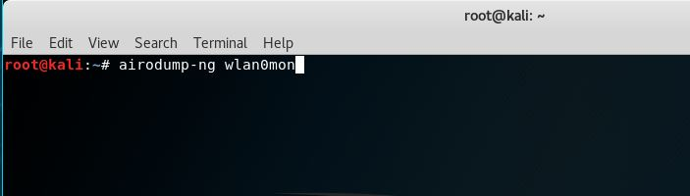

Figure 5 starting airodump-ng

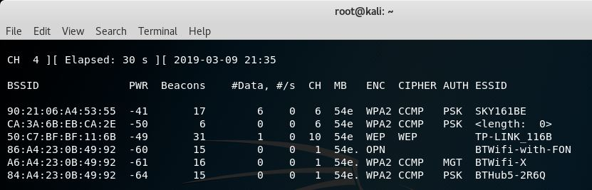
Figure 6 identifies that one of the networks scanned is currently using wired equivalent privacy (WEP), as mentioned throughout the literature review using WEP does pose some significant security risks for SMEs.
Figure 6 scanning target network

4.2 WEP Exploitation
The exploitation phase required the use of besside-ng, besside-ng is a tool used to exploit wireless networks. This tool allows the attacker to brute force WEP and WPA encryption, the attack used to exploit the network was Initialisation Vector brute force. Employing the use of besside-ng payloads allows the attacker to define parameters to identify the target network. The parameters inputted were “besside-ng wlan0mon -c 10 -b 50:C7:BF:BF:11:6B”, -c is used to identify the targets broadcast channel and -b is used to target a specific wireless network address. As mentioned throughout the literature review, the logic behind this attack being viable is as result of WEPs lack of key management and the ability for attackers to spoof initialization vectors to attempt to retrieve the key once the correct vector is sent WEP reveals the key to the attacker. The cracking of WEP only took besside-ng 00:02:51.
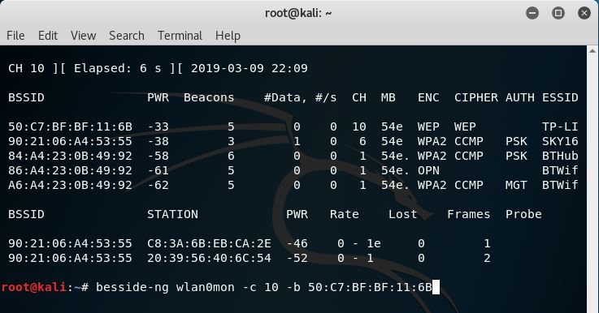
Figure 7 using besside-ng to launch attack

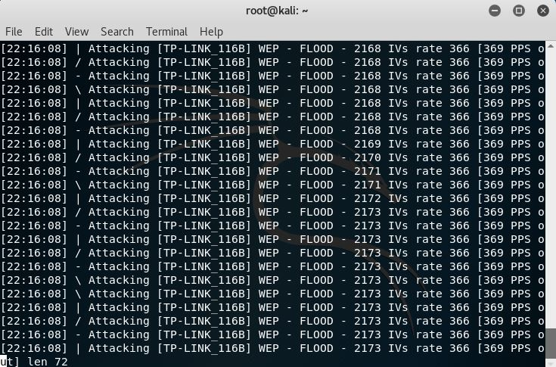

Figure 8 initialization vector brute force
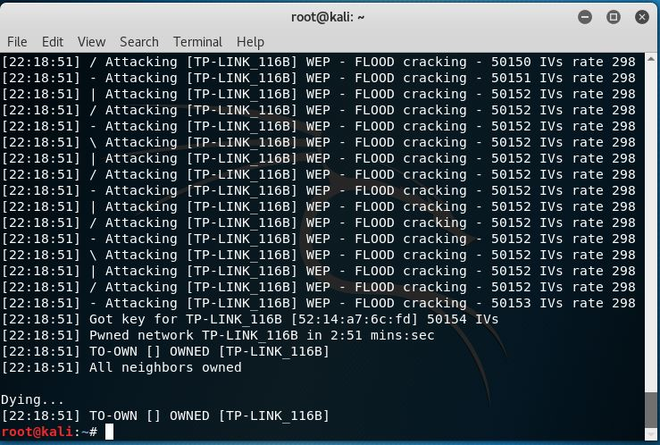

Figure 9 successful exploitation

4.3 WPA Reconnaissance
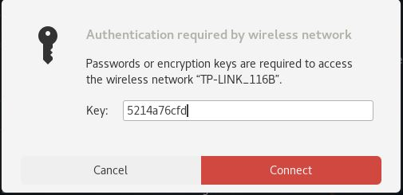
WPA reconnaissance was achieved using Airodump-ng to scan available wireless networks. From the information obtained throughout this stage will be used within the exploitation phase. The obtained information from this stage is the same as the previous WEP crack, the target network appears to be using WPA2 but the cipher to encrypt data is TKIP.
Figure 10 Connection attempt
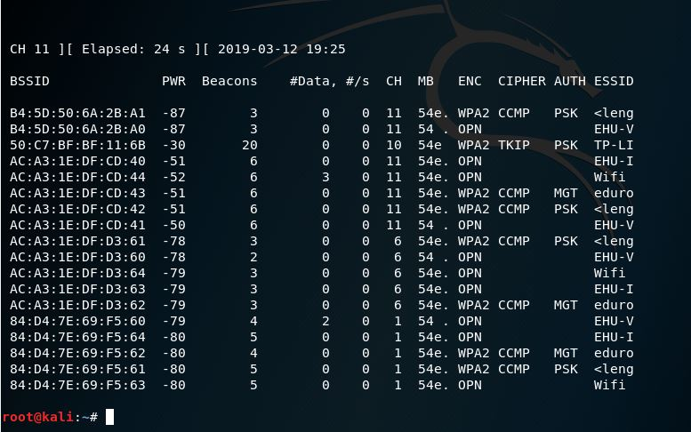

Figure 11 Scanning WPA wireless network

4.4 WPA Exploitation
The WPA exploitation section takes advantage of the scenario SME using only TKIP to secure their wireless network. The attack to be employed will be offline brute force attack, to initiate the attack parameters need to be entered to use Airodump. Airodump is primarily used to capture raw frames, in this scenario the parameters used were -c to select the target networks channel. The –bssid parameter was used to identify the target network, the -w is used to dump the captured four-way handshake to a specific location. In this scenario the files have been dumped to the desktop, the file name is capture.
Once the four-way capture was initiated you must wait for a connecting client, referring to figure 13 a connecting client has been identified as BSSID F8:34:41:2A:CE:16. To capture the four-way handshake the client already connected needs to be de-authenticated, to do this Aireplay-ng shall be used. Aireplay-ng is used to create fake traffic to initiate a de-authentication attack. Referring to figure 14 to commence the de-authentication parameters needs to be entered, the parameters used are -0 to identify the attack is de-authentication. Another 0 is entered to enable the attack to be continuously send the de-authentication packets, then -a is used to identify the target network. Figure 15 details the sending of de-authentication frames, this attack is viable due to vulnerabilities in WPA security allowing for management frames to be accepted by the access point.
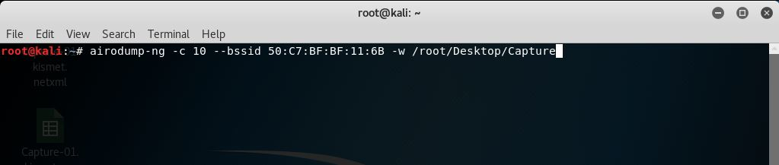
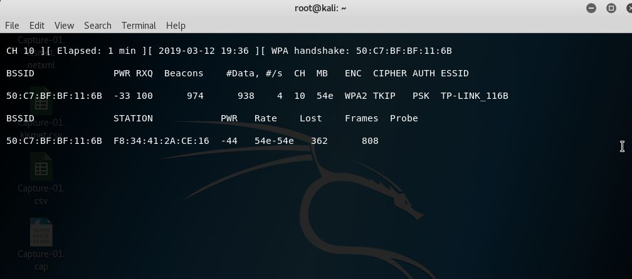
Figure 16 provides evidence of the password attacking files used, this file is freely available to download from GitHub, the file contains 12,000 randomly generated passwords. The passwords are eight characters long and are a mixture of alphanumeric. Figure 17 shows the file containing the four-way handshake and also the password file used. The application used to crack the captured four-way handshake file is named Aircrack-ng, this application is designed to perform this type of offline dictionary attack. The parameters used within Aircrack were -w, this is used to identify the password file used to exploit the captured handshake. Figure 18 shows the successfully cracked password of WPA, the crack only took 16 seconds and the number of passwords attempted before this was 11,596.
Figure 12 using Airodump-ng to capture four-way handshake
Figure 13 successful capture of handshake
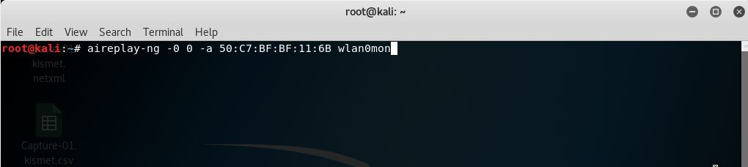
Figure 14 using aireplay-ng to send de-authentication frames to target

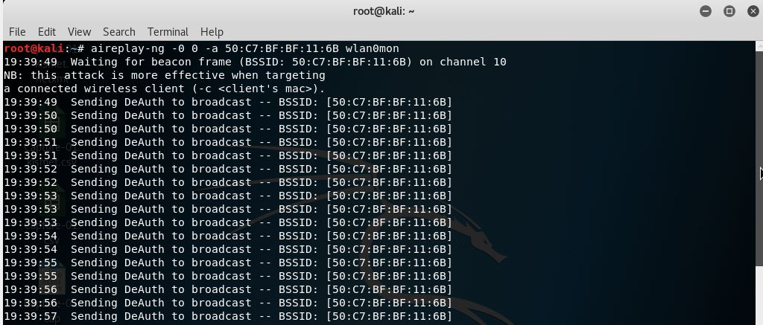
Figure 15 sending de-authentication frames

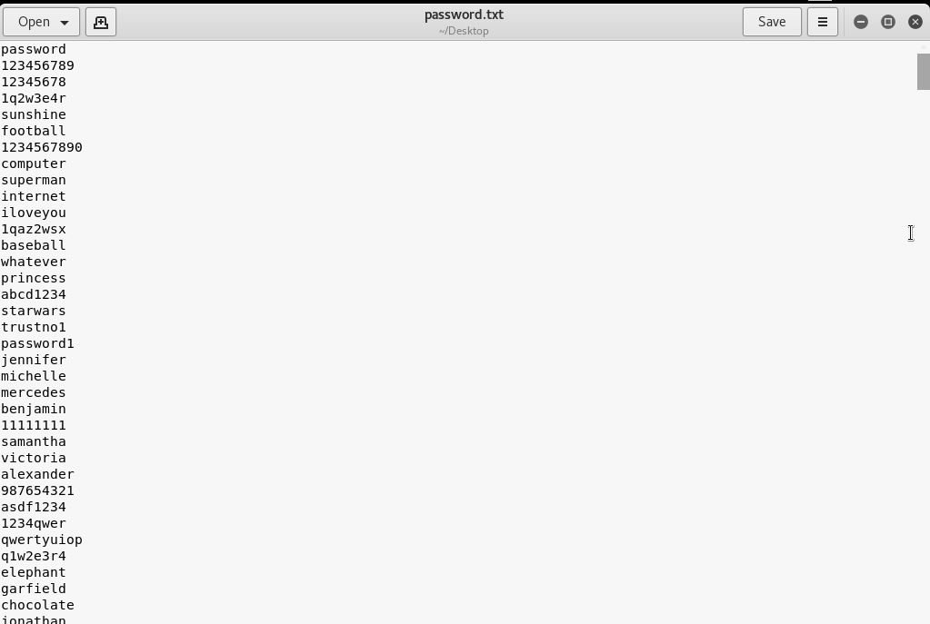
Figure 16 password file used to exploit four-way handshake

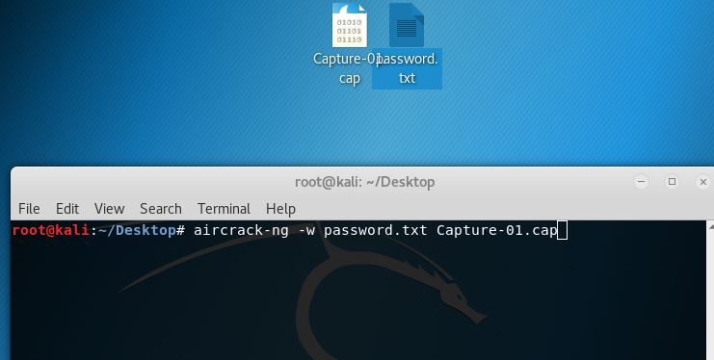
Figure 17 using Aircrack-ng to brute force four-way handshake

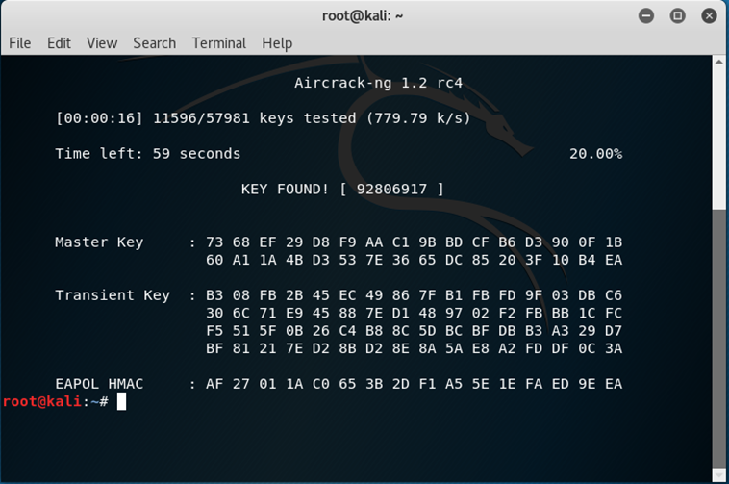
Figure 18 successful four-way handshake exploitation

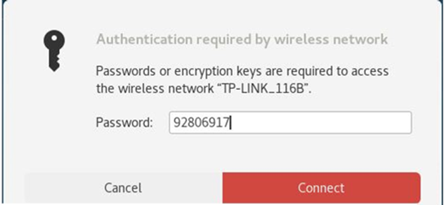
Figure 19 attempting to connect to target network

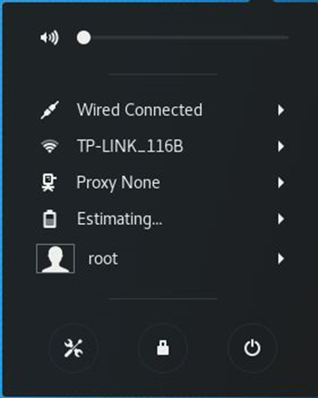
Figure 20 successful network connection

4.5 WPA2 Reconnaissance
Using Airodump-ng allowed the attacker to search for available wireless networks, in this scenario the target networks security settings have been changed to WPA2 using cipher CCMP. The information established from this stage will be used throughout the exploitation stage, the most important information gathered for the PMKID attack is the BSSID to identify the network.
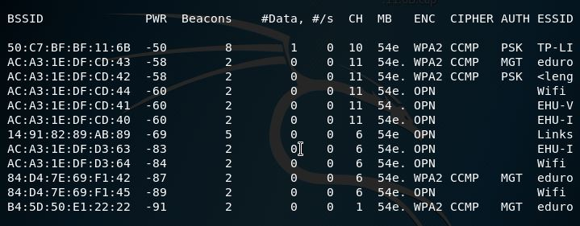
Figure 21 network scan

4.6 WPA2 Exploitation
The exploitation stage requires the use of hcxdumptool, this tool is designed to be a small tool to capture packets from wireless devices. This tool has been used in the exploitation to capture the PMKID, technical details of this attack have been provided throughout the literature review. The parameters entered to use the tool are -i to select the wireless card interface to use, -o is used to select the name of the outputted file pmkidcapture.pcapng. –enable_status=1 is used to establish what should be captured, in this scenario =1 signals the capture of EAPOL frames. To identify the target the attacker needs to create a target list using the BSSID of the target, --filtermode=2 allows the use of targetlist.txt. Present within this file is the targets BSSID, the last parameter -c 10 selects the target networks broadcast channel.
Using the PMKID file that has been captured in figure 22 named pmkidcapture.pcapng another tool needs to be utilized to convert the file type. This tool is named hcxpcaptool, this tool is used to convert the file type, so it becomes compatible with hashcat. Referring to figure 23, the parameters used to convert the file were -E,-I, and -U these parameters are used to purge the PMKID of irrelevant information. The -Z parameter requires a name for the newly converted file and the name of the file to be converted.
Figure 24 provides evidence of the attack against the PMKID, the password attacking tool used is hashcat. Hashcat is a tool developed to crack a large variety of hash types, the types range from MD5 hashes to network protocols. The attacking vectors used within the attack are -m, this parameter is used to identify the mode of attack. The mode selected is 16800, this mode is used to crack PMKID hashes. The next step requires the file directory of the file converted using hcxpcaptool, the file was named pmkidoutput.16800. The -a parameter is used to identify the attacking mode, -a 0 puts the attack mode as straight. Other options for attack modes are straight, combination, brute force and hybrid wordlist. Research conducted regarding hashcat does instruct the user to select attack mode straight, this is a result of the specification of the machine being used to crack the hash. If an attacker selects brute force, for example the attack fails using this mode due to the attack requiring a graphics card. Other attack parameters used within the attack are –kernel-accel=1, this attack parameter is used to establish the workload profile. In this scenario the workload has been set to 1 performance low, this is due to the machine used throughout the attack not having a dedicated graphics card.
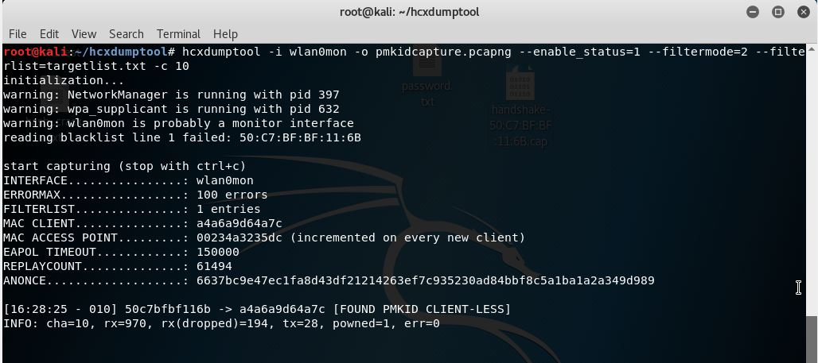
Figure 22 using hcxdumptool to retrieve PMKID
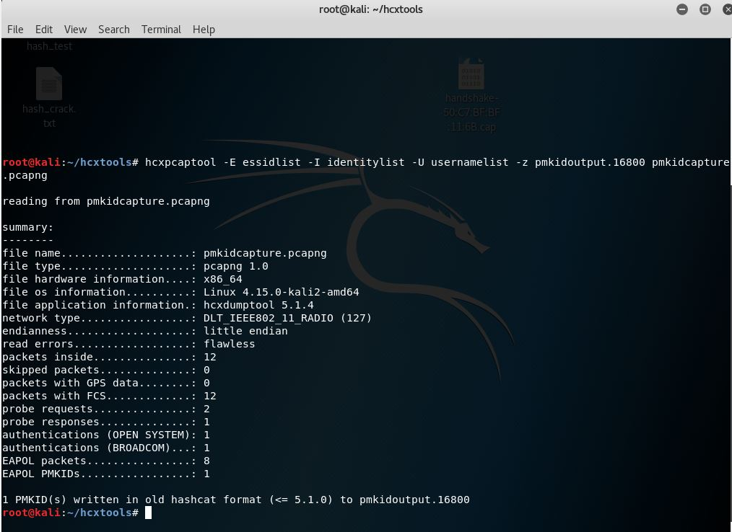
Figure 23 using hcxpcaptool to write captured PMKID to hashcat format
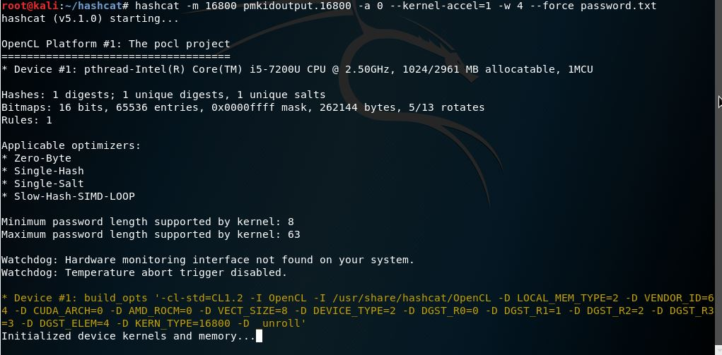
Figure 24 starting hashcat to crack target network PMKID

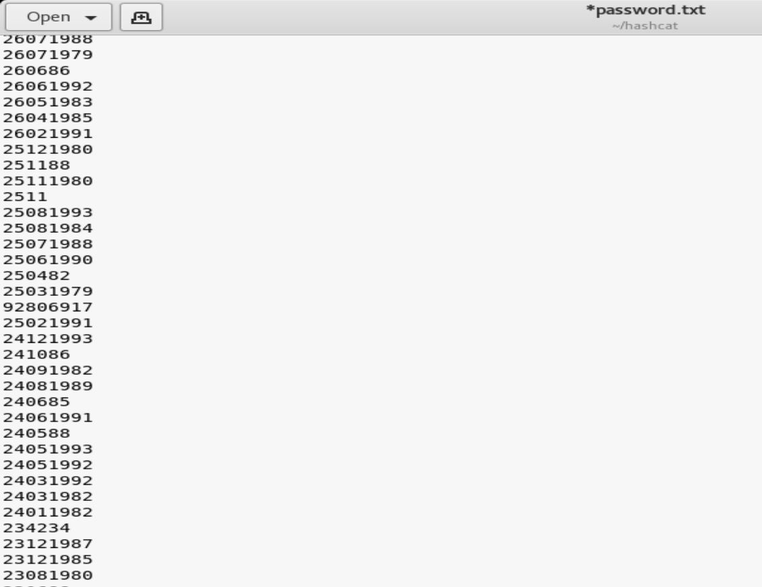
Figure 25 password file used to exploit PMKID

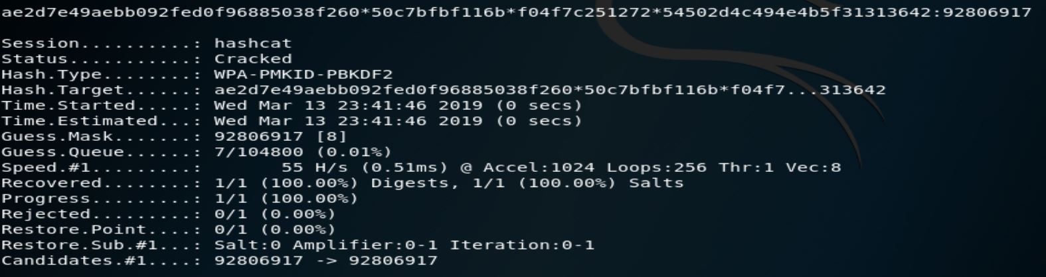
Figure 26 successful network exploitation

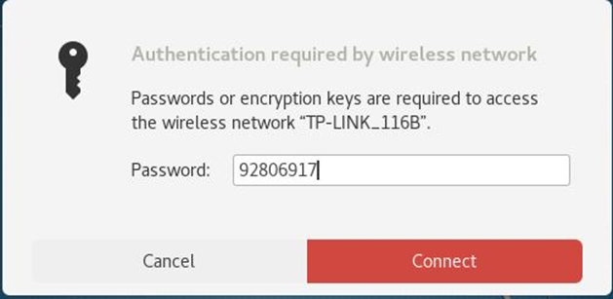
Figure 27 retrieved password entered

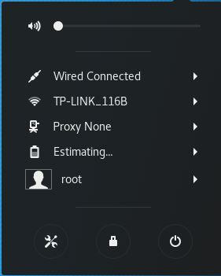
Figure 28 authentication successful

4.6 Implementation Analysis
Figure 9 Presents the simulated attack data, the data that can be retrieved from the simulated attack is that WEP is seriously vulnerable against initialization vector brute force. The WEP key was cracked using Besside-ng, the attack only lasted 00:02:51 and the key was retrieved. Credit can be given to the tool used Besside-ng successfully sent 50,153 initialization vectors to brute force the key. Using this evidence gathered from the simulated attack the WEP security standard can be criticized to be vulnerable to exploitation. The cause of the vulnerability within WEP is the lack of reply detection, allowing the attack to continue to brute force the security standard until the correct initialization vector is found.
Results from figure 13 provides evidence against a vulnerability in WPA allowing an attacker to capture the four-way handshake, the time taken to capture the handshake was 00:01:00. This attack is variable based only allowing the capture of legitimate clients that are connected to the network, if the network is clientless the attack is not viable. Figure 16 presents the password files used to exploit WPA, to analyse the file every password throughout is 8 characters long. This is due to most default router passwords are 8 characters long. Figure 18 shows an overview of the attack performed against WPA, the attack does prove to be successful to crack the PSK. The most alarming result from the simulated attack is the speed that Aircrack-ng is capable of, the results reveal that the key was found in 00:00:16 the more significant result is that Aircrack-ng successfully attempted 11,596 passwords within that time frame. These results do assist to prove the research thesis but for SMEs the results do prove to be alarming for those who use inadequate Wi-Fi security. To comment of the security level of WPA the simulated attack has proved the standard to be vulnerable to the four-way handshake attack, this attack is viable as a result of no management of de-authentication frames.
The recently discovered attack against WPA2 exploits the authentication process by capturing the PMKID as mentioned throughout the literature review, figure 22 reveals the capture of the PMKID of the target wireless network. The figure reveals that to capture the PMKID to exploit the PSK the wireless network can be client-less as the figure shows, this attack provides a new approach to exploiting WPA2. This is a result of the attacker now does not need to capture the four-way handshake. As shown in figure 26 hashcat has successfully exploited WPA2, due to reassembly of the password file the key was cracked in only 7 attempts of the password file. This attack only lasted 00:00:00:51, this is due to hashcat utilizing computer hardware to commence the crack. It can be deduced from the attack that although hashcat did crack the file in less time than other attacks, the attack does indeed have more steps to exploit the network.
Figure 29 presents a breakdown analysis of the time taken to perform the password cracking for each security standard, closer inspection of figure 29 reveals that to crack WEPs key the cracking process takes 00:02:51. Whereas, to crack WPA the time was 00:00:16 yet the crack time for WPA2 only lasted 00:00:00:51. The defining factor among the two attacks is WPA successfully attempted 11,596 passwords whereas, WPA2 only attempted 7. To calculate a fair test, if the WPA2 exploit attempted 11,596 passwords the attack would have lasted 00:00:83, the expression is displayed in figure 30 the variables used are T = time, PA = password attempts and CA = cracked attempts. To analyse the result of the attacks, surprisingly the attack that lasted the longest was WEP. The reasoning for this result is the nature of the attack used against WEP, the key was not brute forced, instead the attack exploited initialization vectors. To evaluate the WEP attack it would be an absurd recommendation to recommend using WEP to secure wireless network based upon the data gathered. To correlate the results from the WPA and WPA2 attacks it can be stated that the WPA attack only lasted 00:00:16, whereas the WPA2 attack took 00:00:83. The conclusion to be taken is that WPA appears to be the weakest Wi-Fi standard to use, it can be criticised that due to the different attack methods used, this could be the reasoning behind the difference in time taken. The WPA attacked used Aircrack-ng whereas, the WPA2 attack used hashcat.
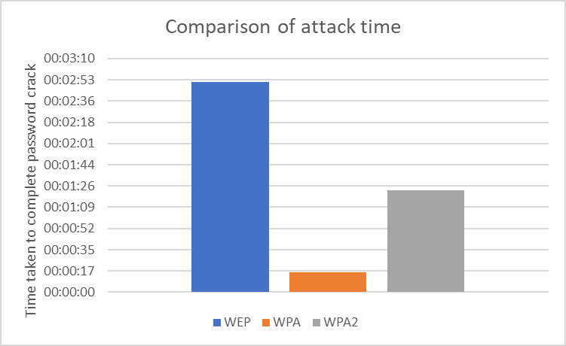
Figure 29 attack time comparison
Figure 30 expression
$$\frac{T}{PA}×CA$$

5. Data Gathered
The section below will display data gathered throughout the quantitative questionnaire and the qualitative simulated Wi-Fi attack, the data has been obtained using different methods to provide a better analysis, this method is named triangulation. The questionnaire has been created using Google forms, this software allows the user to distribute the questionnaire using email. As a result of the data obtained the participating SMEs will continue to be anonymous even throughout the analysis stage. The data will be analysed to produce the end result of the study to create a best practise guide to assist SMEs when configuring wireless networks. This is done to assist the SMEs to achieve the best security they can.

5.1 Analysis
The figure below represents the responses from the questionnaire to SMEs, this figure establishes that the SMEs questioned do use Wi-Fi. This question is required so the SMEs can continue to provide adequate results to keep validity. If a SME responded no to this question the questionnaire would submit the results.
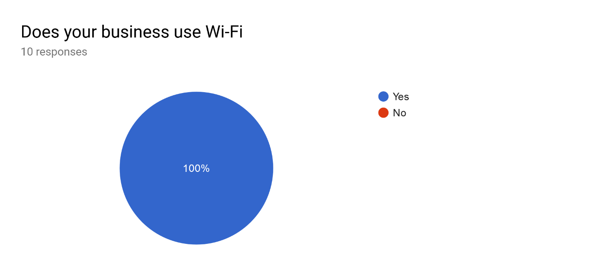
Figure 31 Question 1

The pie chart below Figure 32 shows the breakdown of question 2, this question identifies how participants connect to their Wi-Fi within their business. This question was used to establish if the SME uses enterprise versions of Wi-Fi security, the results present that from 100% of SMEs questioned 70% of SMEs use standard editions of wireless security whereas 30% of SMEs questioned emerged to be using enterprise editions of security. The enterprise versions require authentication via a radius server this prompts the user to input a username and password to authenticate to the wireless network. The assumption was made that no SMEs would use a radius server for Wi-Fi, due to its cost and complexity of implementation. Figure 33 identifies that every SME questioned uses the same password, question 2 could have been misinterpreted by the participants. The assumption is made that the participants may have thought that the username is the networks SSID.
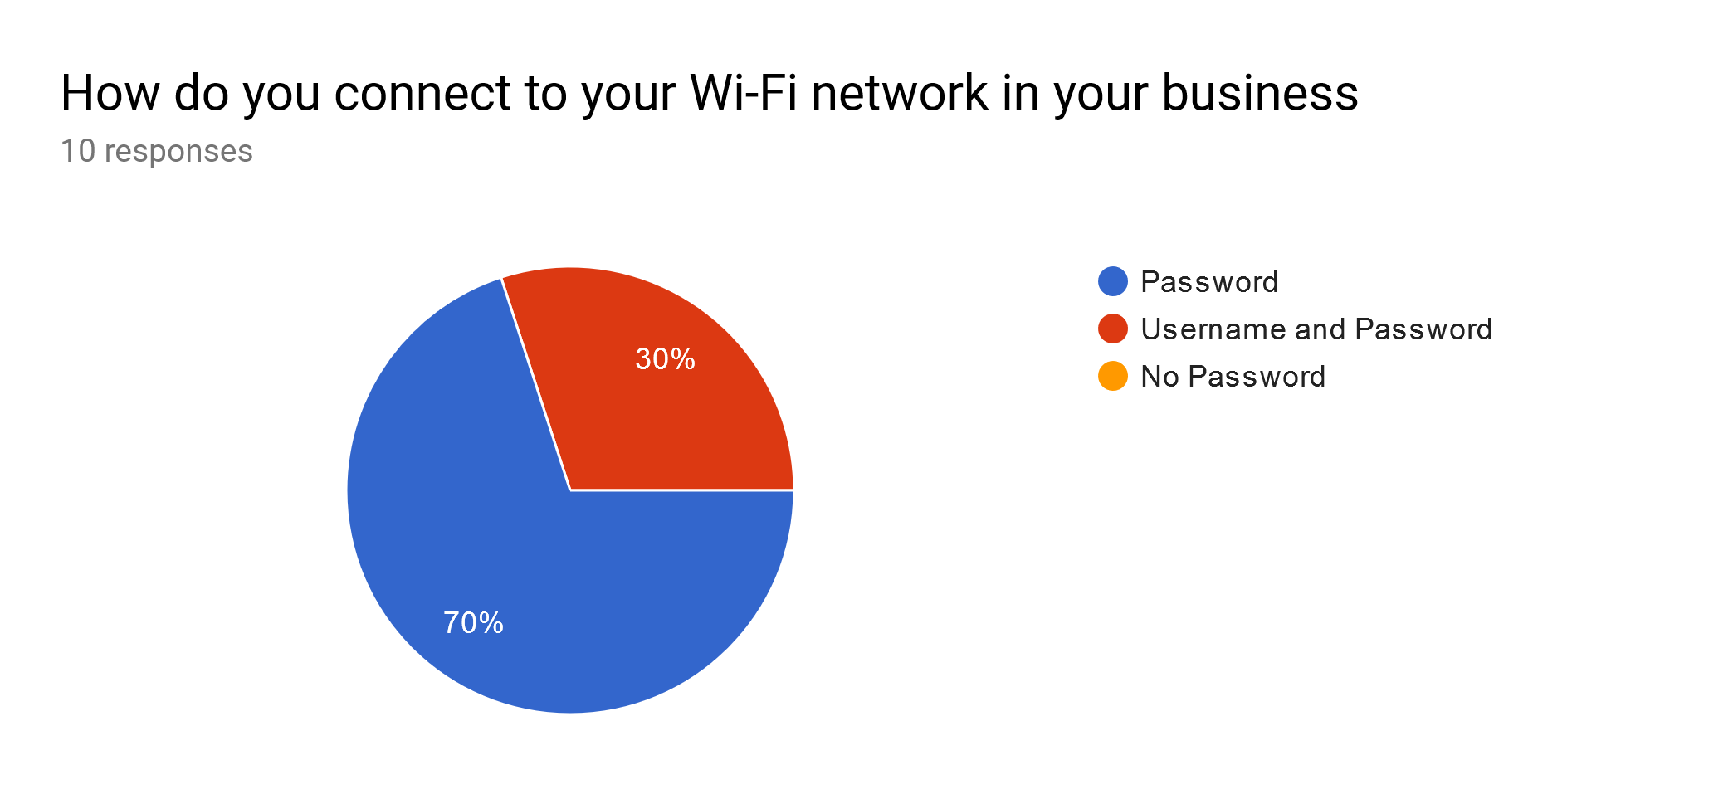
Figure 32 Question 2
Question 3 shows that 100% of SMEs questioned do all use the same password to authenticate to their wireless network, the rationale for this question was to establish if the SMEs use WPA2 PSK rather than WPA2 enterprise. The results from this question do indeed reveal that all SMEs questioned use the standard version of security available by using a pre-shared key rather than enterprise versions. To analyse this question, the results do prove to confirm the assumptions of the underlying research thesis that SMEs do have inadequate Wi-Fi security practises. This is due to SMEs sharing the same password, this would only require a hacker to exploit one Wi-Fi password rather than multiple passwords. It can also be assumed that the Wi-Fi password within the SMEs is common knowledge due to every staff member connecting using the same password.

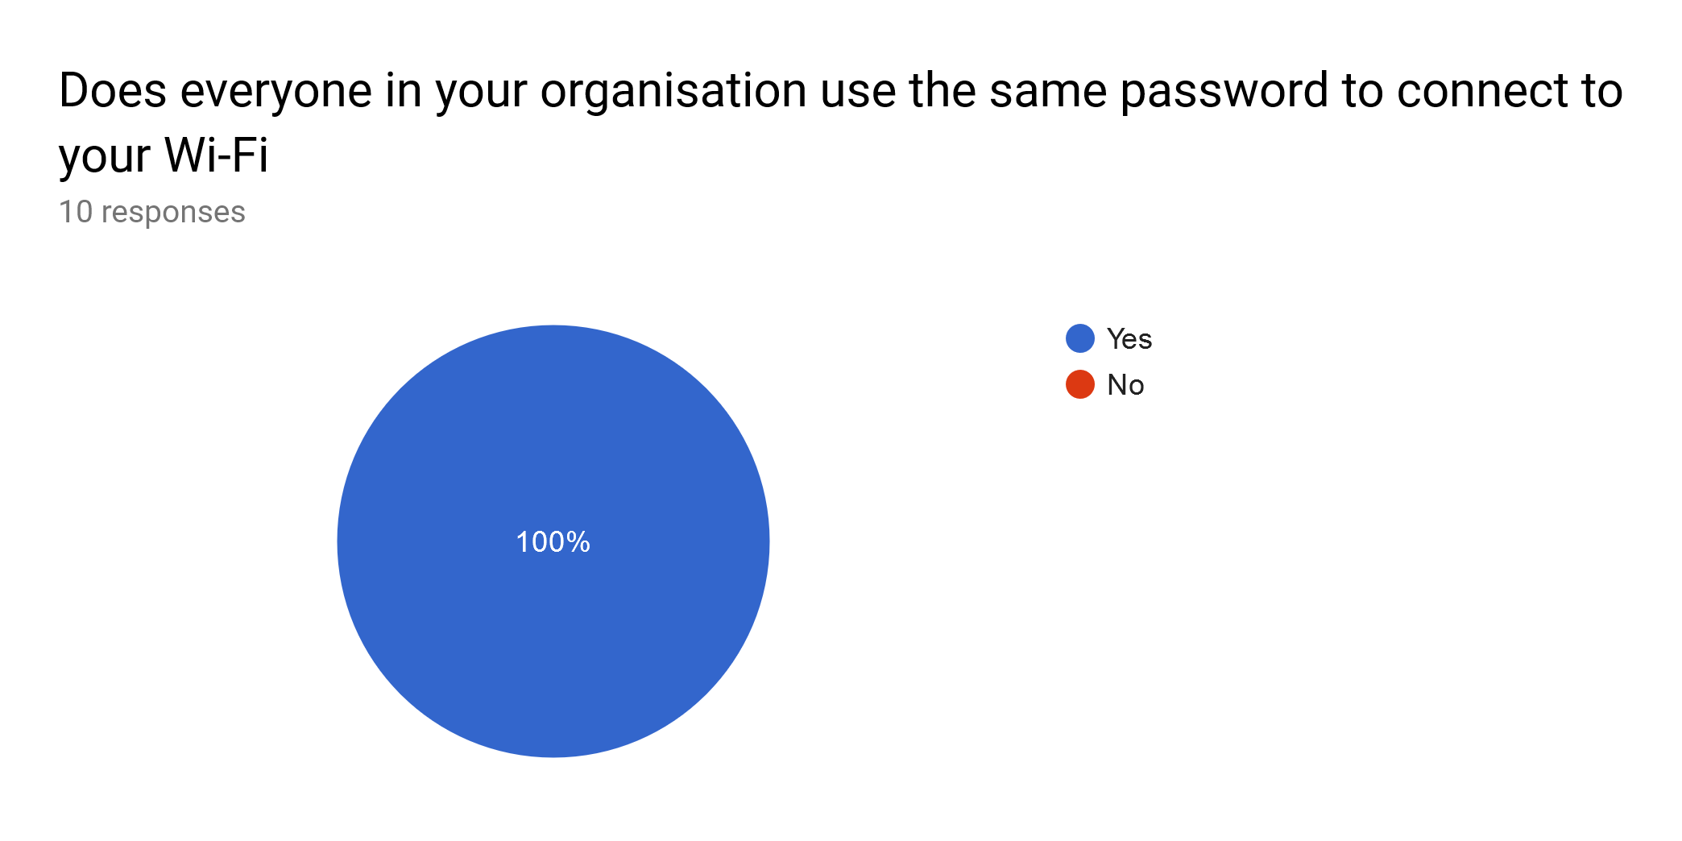
Figure 33 Question 3
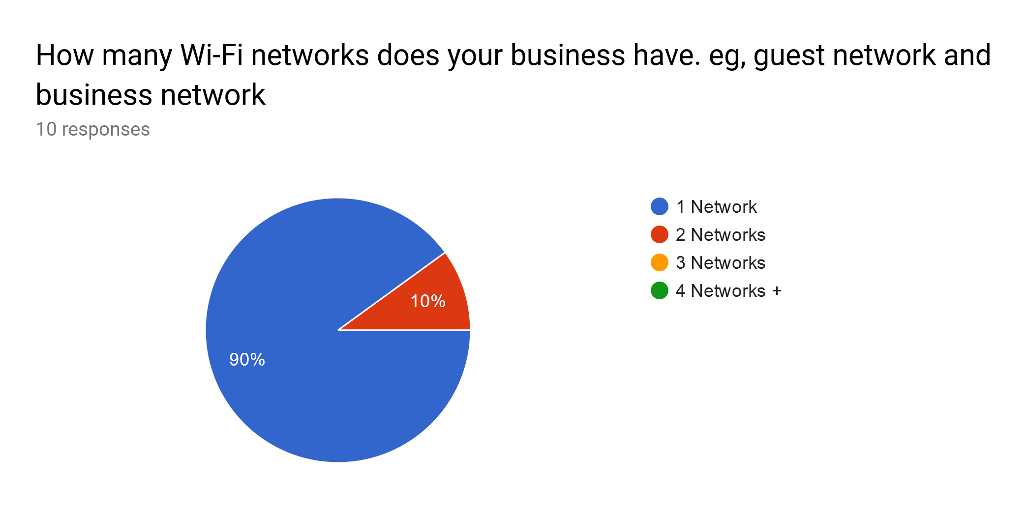
The rationale for question 4 was to establish how many Wi-Fi networks SMEs questioned have, the results do display that from 100% of SMEs questioned only 10% have two wireless networks. Whereas 90% of SMEs do only have one wireless networks. To analyse the questions results it does reveal that 90% of SMEs use only one wireless network for everything within their business, this reality does pose some significant security risks. Comparing results from question 3 in combination both results reveal considerable Wi-Fi bad practises. To analyse the results of question 4 from another perspective, due to the popularity of bring your own device only having one Wi-Fi network could be viewed as a disadvantage and a security risk. But this can also be perceived as advantage were SMEs only have to manage one wireless network rather than four. The affecting factor of the responses from this question may result from SMEs lack of capital, the assumption is made that SMEs only have one wireless network due to the added expenditure of having more wireless routers and internet connections.
Figure 34 Question 4
The results obtained from question 5 certainly show a mixture of results, the reasoning for this question is to provide the research with data regarding Wi-Fi security practises. Results from 100% of SMEs questioned 20% of SMEs do not know if their Wi-Fi password has been changed from the manufacturers default. The assumption has to be made that the 20% of SMEs questioned do not know if the password has been changed this could be due to lack of technical ability or knowledge, on the contrary there is the possibility that managers do not allow staff to have access to any network equipment thus resulting in the staff member simply not knowing the Wi-Fi configuration. The more alarming results from this question shows that 80% of SMEs questioned do not change their Wi-Fi default password, theses results gathered do prove similar from those from the literature review. The analysed literature does concur that poor equipment configuration does lead to security breaches. In correlation of analysis question 3 and questions 4 do provide evidence on the inadequate security practises of SMEs, when all staff in the SME share the same password and that password is never changed. These findings confirm that the SMEs questioned are vulnerable to brute force attacks using common password dictionaries to exploit their network. The more surprising correlation from question 4 and 5 reveals that 10% of SMEs have two wireless networks, when analysing question 5 it displays results that 80% of SMEs do not change their default password. The evidence gather does prove to be alarming that SMEs have more than one wireless network and the password has not been changed, this proves to reveal inadequate security practises from the SMEs. When using two wireless networks it is assumed that one is used for business operations and the other is used for guests, this could lead to network exploitation. Other vulnerabilities from the data present in question 3 and 5 reveals that SMEs using the same password to authenticate to the network. Responses from question 5 displays that SMEs using the same password and never changing that password allows the SME to even be exploited by disgruntled staff. For example, a disgruntled employee whose employment is terminated could exploit the network by knowing the password and knowing that it is never changed, this concept displays another angle of attack against the SME.
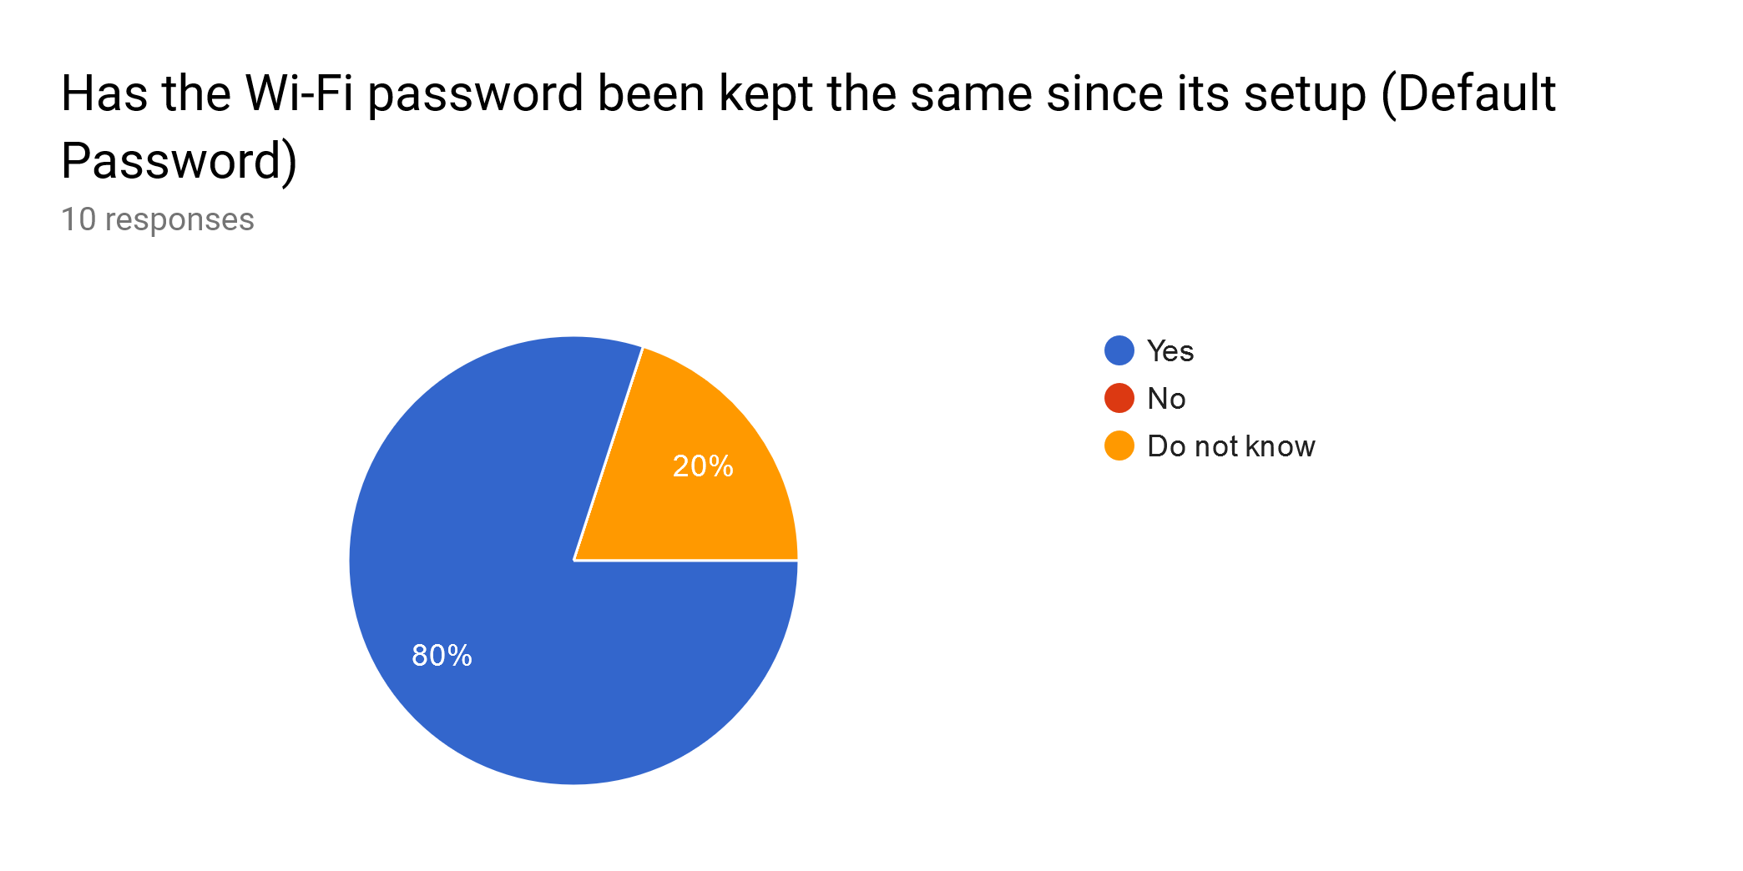
Figure 35 Question 5

The data gathered from question 6 reveals that 80% of SMEs questioned do not have technical support within their business, the reasoning behind this question Is to determine correlation from previous question results. The results show that 80% of SMEs do not have technical support within their business, whereas 20% responded that they do have technical support. Surprisingly 0% of SMEs have telephone technical support, this is surprising as the reader can deduct that having telephone support would be more cost effective rather than employing an onsite technician. To identify similarities throughout questions it can be revealed that question 5 and question 6 do coincide to present similar results. For example, question 5 divulges that 20% of SMEs do not know if their Wi-Fi password has kept its default password. This analysis shows that 20% of SMEs questioned do not know if the password has been changed due to their technical support performing the task rather than employees. The results from question 5 and 6 on the contrary do also reveal that 80% of SMEs do not have technical support onsite, whereas 80% of SMEs Wi-Fi passwords have been kept the default. To corollate this data it is revealed that SMEs that have kept the default password do not have onsite technical support, this reveals that SMEs are vulnerable to Wi-Fi attack due to inadequate configuration. Analysing the data captured it can also be deducted that this exhibits inadequate use of security policies and procedures, other deductions that can be made are that SMEs do not have the capital to employ an IT technician this could be a factor to consider when SMEs have inadequate security practises. In comparison from question 3 every staff member uses the same password to connect to Wi-Fi, responses from this question establish that one password is used throughout the SME. Question 6 revealed that 20% of SMEs have onsite technical support, even though the SMEs that have technical support use the same password within the SME. Some criticism can be given regarding the quality of technical support that the SMEs receive, the technical support staff may also have inadequate Wi-Fi security knowledge allowing the SME to use the same password or even the default password. The assumption is made that these findings are a result of lack of capital from the perspective of the IT technical support department, that the SME does not have the funding to justify upgrading Wi-Fi security.
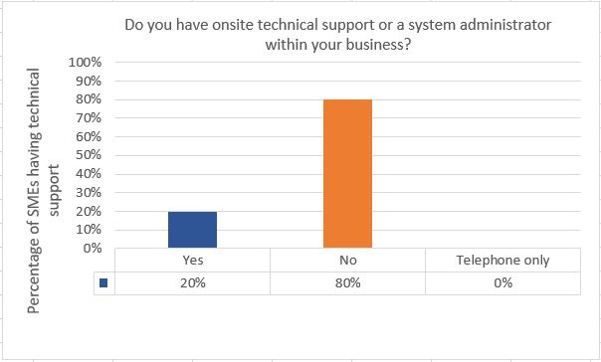
Figure 36 Question 6

The data retrieved from question 7 does expose inadequate security practises from SMEs questioned, the rational for this question is to analyse Wi-Fi security practises and to identify patterns and similarities from previous questions. The findings display that 90% of SMEs questioned do not change their default router password, whereas 10% percent of SMEs change the password once every year. Closer inspection of the data reveals question 3 and 7 in comparison have some similarities, the similarities identified are that 100% of SMEs questioned used the same password to authenticate to the Wi-Fi network. Whereas question 7 reveals that 90% of SMEs responded never when asked “how often do you change your Wi-Fi password”. Analysing further it can be deduced that issues arise when staff can connect to business-critical network, mentioned previously bring your own devices phenomenon could cause the SME to experience cyber attacks when staff can connect to business network. As said this is an assumption but the theory does prove relevant. Other relevant points to take from question 3, due to the data present every staff member uses the same Wi-Fi password to connect. This freedom staff have could allow them to connect multiple devices to your business internet, this end result from the inadequate use of policies and procedures could result in slow internet bandwidth that affects business productivity. Question 6 and question 7 show relationships between 20% percent of SMEs have technical support, and the 10% of SMEs that change their Wi-Fi password every year. This reveals excellent security practises from SMEs that have onsite technical support, the assumption Is divulged that the SMEs without technical support cannot justify the added expenditure. Surprisingly question 7 does appear to reveal high results of inadequate security practises, the reasoning for these responses cannot be funding issues as changing a Wi-Fi password does not cost. Whereas the SMEs technical skills can be questioned, the SMEs may not know how to change the default password. The data provides justification for the creation of a best practise Wi-Fi security guide for SMEs.
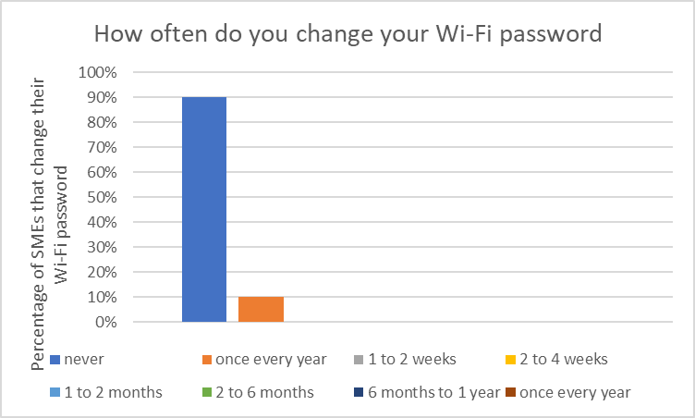
Figure 37 Question 7

Using the deduced data from Question 8 that 100% of SMEs have a Wi-Fi password that is only 6 to 12 characters long, the reasoning for this question it to retrieve data regarding Wi-Fi security password practises. Using question 8 results to correlate other questions, evidence from question 7 reveals that 90% of SMEs never change their Wi-Fi password. Other evidence to be compared is question 3 and question 5, 80% of SMEs passwords have been kept as default and 100% of SMEs use the same password to access network. From the evidence present it can be inferred that the majority of SMEs questioned are currently using the default password to protect their wireless network, previous research analysed established that WPA2 passwords are vulnerable to brute force attacks due to weak selection algorithms used by internet service providers. It can also be assumed that none technical users could change the password to something that is less secure than the default set by the manufacturer, this present issue could be solved by providing SMEs with relevant literature to better secure wireless networks.
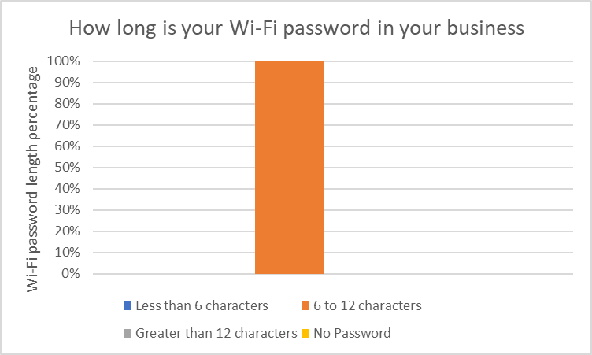
Figure 38 Question 8

The mean responses for question 9 was 50% of SMEs do not regularly update their routers software, surprisingly this question does show a variety of results. 40% of SMEs responded that their routers software never gets updated, whereas 10% responded they update their software once every year. The rational to use this line of questioning was to verify if SMEs questioned are vulnerable to the recently discovered Krackattacks, this attack was mentioned throughout the analysed literature. The attack does not exploit the encryption mechanism of Wi-Fi, instead the attack exploits the software used to attempt to replay four-way handshake messages. The evidence present from the data does reveal that 40% of SMEs are vulnerable to krackattack, results can be analysed to reveal that SMEs may not know how to update router software to mitigate this attack. The only relevant data gathered from question 7 and 9 in comparison is that, SMEs display inadequate security practises that leave the SME vulnerable to hacking attacks. From the SMEs perspective it is assumed that to install and configure a wireless network all that is necessary from the SME is to plug into power, these results prove to enforce the recommendation that the creation of a best practise guide would benefit SMEs. This is a result of the lack of technical skills and knowhow the majority of SMEs have.
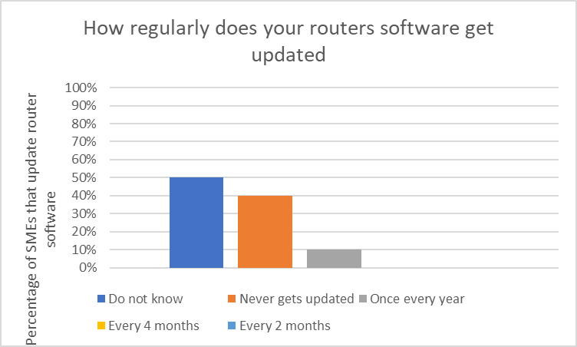

Figure 39 Question 9

Question 10 presents the statistics for the SMEs questionnaire, the question was “What Security does your Wi-Fi use”. The reasoning behind this question is to examine any links between Wi-Fi security weaknesses and configuration of encryption settings. The statistics collected demonstrates the Wi-Fi security of the SMEs questioned, the results collected reveal that 10% of SMEs are using WEP to secure their wireless network. As previously mentioned throughout literature review, several authors suggested that using WEP to secure wireless networks is a genuine threat to security and should be mitigated immediately. The presumption formed from the retrieved data reveals that 0% percent of SMEs use WPA, in contrast 40% of SMEs do not know what security mechanism they use. This reveals that the 40% of SMEs that do not know could potentially use WEP to connect to their network. On the contrary the data could also imply that the 40% of SMEs that responded do not know could also use WPA. There was a significant correlation between question 5 and question 10, the results revealed that 50% of SMEs use WPA2. These findings reveal positive results that 50% of SMEs do use WPA2, in comparison question 5 reveals that 80% of the SMEs questioned do not change their default password. Even though the SMEs are using the most recent security standard this still leaves the SME vulnerable to Wi-Fi attack due to default password not being changed. The evidence present also highlights that SMEs are not familiar with their Wi-Fi configuration, 40% of SMEs responded do not know when asked about their Wi-Fi configuration. The SMEs that responded, do not know could been seen as being ignorant about their security configuration. This conclusion can be arrived at by understanding that the questionnaires are used to allow the SMEs to fill out the questions at their convenience within the SME, whereas the SMEs that responded do not know it is assumed that the responded did not check their configuration before responding. Thus, the evidence revealing that the SMEs are ignorant to Wi-Fi security and the SMEs are not technically minded.
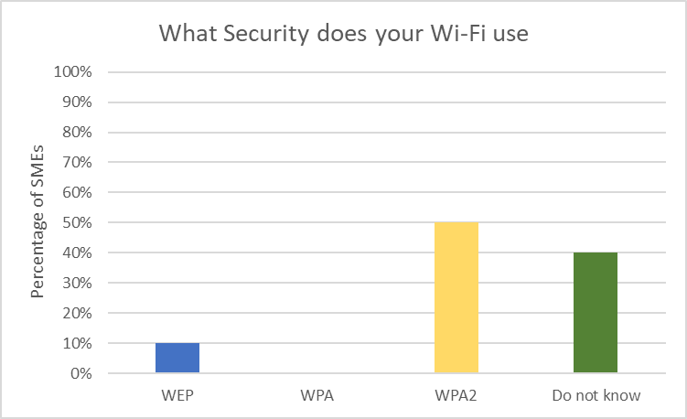
Figure 40 Question 10

6. Findings
This section will present the findings that has been retrieved throughout the overall project, the chapter will include literature review analysis, SMEs questionnaire and simulated penetration test. This will be achieved by using methods of triangulation to reveal how each research method coincides to give an in-depth explanation of the research findings. The aim of the research was to examine the importance of using the most secure security method for Wi-Fi within SMEs, the rationale for the research is the discovery of new attack vectors discovered in 2018. The research objectives are to provide evidence that SMEs are vulnerable to Wi-Fi exploitation due to lack of knowledge and capital, the output from the research will provide SMEs with a best practise guide to assists SMEs to securing their wireless networks, the findings from the entire research will be used to create the guide.
There is a large volume of published studies that highlight the vulnerabilities of WEP, referring to the analysed literature the vulnerabilities mentioned is the ability to capture initialization vectors. This weakness enables attackers to brute force the WEP key, other flaws discovered is that WEP uses static keys. Figure 40 question 10 from the SMEs questionnaire presents results that reveal 10% of SMEs questioned still use WEP to secure their wireless network, these results are alarming due to WEP being released in 1997 and it is still being used today. The simulated attacked commenced against WEP was completed using a vulnerability discussed throughout the literature review, the initialization vector brute force attack lasted only 00:02:51. From the perspective of the SME still using WEP, this reveals that the findings do pose a significant security risk. Other evidence suggests that the reason for this present vulnerability could be because of the SMEs not having technical support, figure 36 provides evidence that 80% of SMEs do not have technical support. The correlation between lack of appropriate security measures and not having technical support can divulge the reasoning behind the research thesis, due to SMEs having limit technical knowledge and not enough capital expenditure to pay for technical support the vulnerabilities remain.
The literature analysed does provide some mitigation methods to defend against the weaknesses of WEP, the mitigation process used is to recommend organisations to upgrade their wireless technology to employ the use of WPA. Eventually weaknesses were discovered within WPA, these weaknesses are the use of the RC4 cipher. This cipher was also used within WEP the difference being WEP did not use the TKIP protocol, the findings do certainty prove to provide evidence to the statement that Wi-Fi is inherently not secure and has always had security problems.
Comparing findings from the literature review and simulated attack, the vulnerabilities discovered throughout WPA are a genuine threat to SMEs. The vulnerabilities discovered allow attackers to de-authenticate legitimate clients, upon reconnection the attacker retrieves the authentication packet. Once the attacker has the packet taken from a legitimate client the attacker can commence an offline brute force attack, referring to figure 18 the PSK of the wireless network was cracked. The cracking process only lasted 00:00:16, the tools used Aircrack-ng attempted 11,596 passwords in that time frame, these results compared with results from the questionnaire do prove to enforce the need of a best practise guide. To comment on figure 37, 90% of SMEs responded never when asked how often do you change your Wi-Fi password. SMEs also responded to figure 35 responding yes to 80% of SMEs leaving their password as the default. To analyse the simulated attack figure 18 demonstrates the capability of the tools used, being able to attempt 11,596 passwords in 00:00:16. The findings reveal that as a result of SMEs inadequate Wi-Fi security practises this attack becomes viable, due to the nature of the attack used attackers could capture the handshake packet and then attempt to crack the file for days maybe even weeks.
Other findings throughout the literature review implies a strong relationship between WPA and WPA2, findings reveal that WPA2 was released to mitigate the vulnerabilities within WPA. On the contrary the literature review does prove to dispute this statement, revealing that vulnerabilities that exist within WPA are also present within WPA2. An example of this is the simulated attack commenced against WPA, the same vulnerabilities are present within WPA2 allowing attackers to launch a de-authentication attack to capture the four-way handshake packet. The findings prove to identify no lessons learned from the implementation of WPA.
An initial objective of the research was to identify security vulnerabilities within Wi-Fi, to refer back to the motivation of the study the recently discovered PMKID attack and KRACK attack prove to genuinely exploit WPA2. The PMKID attack used throughout the simulated Wi-Fi attack proves to exploit WPA2 without connecting to the network, evidence for this is present in figure 22. The PMKID was captured even when the network is clientless, this new attack vector allows attackers to capture the PMKID and not connect to the network. Whereas, the four-way handshake attack requires the attacker to disconnect a legitimate client to capture the handshake. Findings from the SMEs questionnaire, question 10 reveals that 50% of SMEs use WPA2 to secure their wireless network. Results from the simulated attack reveal that the brute force password crack lasted 00:00:83 to find the correct PSK, hashcat successfully attempted 11,596 passwords. This attack does prove to be more alarming for SMEs, referring to the analysed literature to mitigate the vulnerabilities of WPA2 organisations are encouraged to upgrade to WPA2 PMF. This upgrade does mitigate the four-way capture attack by not disconnecting legitimate clients, whereas the PMKID attack proves to circumvent the mitigation by not needing to capture the four-way handshake to initiate the brute force attack. The other exploit discussed throughout the literature proves to be difficult to use due to the security researcher Mathy Vanhoef not releasing the attack script till the vulnerability has been mitigated. The literature does detail that most modern routers are vulnerable to the KRACK attack, the results from the SMEs questionnaire does provide evidence that SMEs are vulnerable to KRACK attack. Question 9 figure 40 reveals that 40% of SMEs never update their wireless routers software, the findings from this evidence does prove that 40% of the SMEs questioned would be vulnerable to a variation of KRACK attack. The mitigation process for this attack requires SMEs to update their wireless routers software.
One interesting finding from the simulated Wi-Fi attack is the comparison of attack times, referring to figure 29 the attack times from the three different simulated attacks reveal that the longest attack time was WEP lasting 00:02:51. To explain this result, this is a result of the attack vector used against WEP is the reason why the attack lasted much longer than the others. To correlate results from the SMEs questionnaire it is evident in question 10 that the majority of SMEs do indeed use the latest Wi-Fi security standard WPA2, the more alarming result is that 40% of SMEs responded do not know when asked this question. To comment on this finding, it can be assumed that the 40% of SMEs that do not know what security their Wi-Fi uses could use the outdated standards such as WEP or WPA. The finding also provides evidence towards the underlying research thesis that SMEs do lack technical knowhow to secure themselves against Wi-Fi exploitation, this result proves to enforce the need for SMEs to have a Wi-Fi security best practise guide.
What is surprising is that throughout the analysed literature, journals do highlight another Wi-Fi security vulnerability. The journals mention that wireless router manufacturers can be criticized, as a result of their default password selection algorithm. The journal details that the algorithms used to select default passwords for routers are inadequate. Findings from the SMEs questionnaire reveals that 80% of SMEs have kept the default password, other findings relating to this issue details that 90% of SMEs never change their Wi-Fi password. The results from the questionnaire reveal that SMEs do not change default passwords, if router manufactures are initially setting weak default passwords this is a cause for security concern. To examine the simulated attack 11,596 passwords were attempted to exploit WPA, this attempt only took 00:00:16. To provide confirmation to the claim the literature is making, appendices 2 provides evidence of a weak passwords set by the router manufacturer. To conclude the above analysis, the findings reveal that SMEs inadequate Wi-Fi practises, the capability of the exploitation tools and the manufacturers using weak algorithms results in vulnerabilities with Wi-Fi used by SMEs.
Findings reveal throughout the literature review that in comparison to WPA2, WPA3 does appear to be the security mechanism to secure wireless networks for years to come. The standard has been upgraded to use SAE and AES encryption has been replaced with ECC. This upgrade referring to table 2 does prove to mitigate all known vulnerability against WPA2, this shows evidence of lessons learned from insecure Wi-Fi implementation. Added security benefits from WPA3 does result in allowing SMEs to genuinely select weak passwords, the Wi-Fi alliance has stated users can select passwords easier to remember and the password is not required to follow complexity standards.
Several studies examined throughout the literature review have anaylsed why SMEs are the first affected by security vulnerabilities, the findings reported do imply a correlation from the SMEs questionnaire and the authors findings. For example, the findings reveal that 22% of SMEs do not know were to start regarding cyber security. This point is made clear from responses received from SMEs questionnaire. One interesting point made from the literature is that when none technically savvy individuals create passwords, they tend to not be very strong. This finding proves that SME employee could potentially change the manufacturers default password to something weaker.
This study set out to analyse and discover if SMEs Wi-Fi security methods are vulnerable to exploitation, the study has proved this to be true using a variety of methods. The study has identified weakness in SMEs Wi-Fi security practises and also the security standards to secure wireless networks. These findings prove to reinforce the need to educate SMEs when it comes to securing wireless networks.

7. Recommendations
As can be deducted from the simulated penetration test and SMEs questionnaire it is revealed that 10% of SMEs use WEP to secure their wireless network, the penetration test results do provide evidence that this security method is no longer secure. The recommendation to make for the SMEs would be to upgrade their wireless router, it is understandable that SMEs may be budget restricted but due to the age of WEP there is no mitigation to protect against its vulnerabilities due to the nature of the initialisation vector brute force attack. Other security mitigation methods discussed throughout the analysed literature is MAC address filtering, this concept would work in theory but requiring SMEs who have been proven to lack technical knowhow may struggle to implement such a mitigation strategy.
Results from the SMEs questionnaire prove to reveal that 0% of SMEs use WPA, on the contrary 50% of SMEs use WPA2 and 40% do not know what security standard they use. To make recommendations based on these findings, SMEs using WPA2 could consider upgrading to WPA3 supported equipment. This upgrade would mitigate the majority of attacks they are currently vulnerable to, the other option would be to use WPA2 PMF. This upgrade would mitigate the risk of four-way handshake exploitation, but the SME would still be vulnerable to the PMKID attack. To partially mitigate the PMKID attack SMEs would be advised to enforce strong PSK selection and to use the two methods mentioned above WPA2 PMF and strong password selection.
To conclude this chapter all mitigation methods discussed above will be present within the SMEs best practise guide to securing Wi-Fi, the guide will be informative and will provide instructions to securing Wi-Fi with annotated images to ensure SMEs best Wi-Fi practises.

8. Conclusion
This study set out to highlight the present vulnerabilities within Wi-Fi security and how SMEs are affected by this as a result of lack of technical knowhow and capital expenditure budgets. The objectives of the research have been achieved, past and present security methods for Wi-Fi have been examined throughout the literature review while mentioning vulnerabilities and mitigation processes. Factors as to why SMEs are vulnerable have also been discussed, the findings from that chapter reveal SMEs are vulnerable due to lack of technical knowhow and capital. To establish what security practises SMEs currently use a questionnaire was sent out using email as a platform, the data retrieved has been anaylsed to reveal the majority of SMEs use WPA2 and 40% responded they did not know the standard they use. This finding proved that SMEs do lack technical knowhow, to correlate the findings from the literature review revealed that 22% of SMEs do not know where to start with cyber security and that the majority of hacking attacks are successful due to misconfiguration of equipment. The simulated penetration test has provided evidence to suggest that the security standards are not adequate enough to security Wi-Fi, to combine all the outcomes of the study the best practise guide will be created to better equip SMEs to deal with Wi-Fi exploitation attacks. The underlying thesis aims and objectives have been completed and the outcome proves successful that SMEs are vulnerable to Wi-Fi exploitation due to a number of factors mentioned above.

8.1 Future research
To continue on from the research commenced above, the author would choose to examine the Wi-Fi attack vector mentioned throughout the literature review, the attack vector is known as KRACK attack. As a result of the security researcher Mathy Vanhoef not releasing attack scripts for the KRACK attack until the exploit has been mitigated, the simulated Wi-Fi attack could not use this vulnerability to exploit the test wireless network. On the contrary the researcher had released vulnerability assessment scripts, but the use of the scripts would not have related to the aims and objectives of the study. Throughout the literature review large amounts of research journals refer to WPA3 being the perfect security solution, this being said the standard does prove to mitigate all previous attack vectors discussed within the literature review. To further the research the author would choose to investigate the security capabilities of WPA3 to examine and reveal lessons learned from previous implementations and to examine SMEs rate of adoptions of the new security standard. To evaluate the effectiveness of the research deliverable, the author would choose to measure the best practise guides efficiency by resending the SMEs questionnaire and reviewing responses from the previous questionnaire to correlate data to measure the guides ability to assists SMEs to securing their wireless network.

References
Adams, W., 2015. Handbook of Practical Program Evaluation. 1st ed. London: John Wiley and Sons.
Aneja, A. & Sodhi, G., 2016. International Journal of Computer Science Trends and Technology. A Study of Secuirty Issues Related With Wireless Fidelity (WI-FI), 4(2), pp. 348-349.
Arana, P., 2006. Benefits and vulnerabilities of Wi-Fi protected access 2 (WPA2), 1(2), pp. 5-6.
Armin, N., 2014. Faculty of Engineering, Mathematics and Computer Science. The Impact of Cyber Security on SMEs, 1(2), pp. 14-15.
Barnes, C. & Bautts, T., 2002. Hack Proofing your Wireless Network. 1 ed. Boston: SYNGRESS.
Blaxter, L. & Hughes, C., 2010. How To Research. 4th ed. London: Open University Press.
Buttyan, L. & Dora, L., 2007. Laboratory of Cryptography and System Security Department of Telecommunications. WiFi Security-WEP and 802.11i, 4(1), pp. 10-11.
Denscombe, M., 2017. The Good Research Guide. 6th ed. London: Open University Press.
Department for Digital, Culture, Media & Sport, 2018. Cyber Security Breaches Survey, London: GOV.UK.
Dobbertin, H. & Rijmen, V., 2004. 4th International Conference, AES 2004. Advanced Encryption Standard - AES, 1(2), pp. 1-2.
Dojkovski, S. & Lichtenstein, S., 2010. 21st Australasian Conference on Information Systems. Enabling Information Security Culture: Influencesand Challenges for Australian SMEs, 1(2), pp. 4-5.
Feher, D. & Sandor, B., 2018. IEEE 16th International Symposium on Intelligent Systems and Informatics. Effects of the WPA2 KRACK Attack in Real Environment , 1(1), pp. 241-242.
Floyd, J. & Fowler, J., 2014. Survey Research Methods. 5th ed. London: Sage.
Heale, R. & Forbes, D., 2013. Understanding Triangulation in research, 16(4), p. 1.
Hewlett Packard Enterprise Company, 2018. WPA3 AND ENHANCED OPEN: NEXT GENERATION WI-FI SECURITY , California: aruba.
HM Government, 2015. Uk Cyber Security, UK: Marsh.
Humboldt University Informatics, 2018. WPA3 Dragonfly Handshake. [Online]
Available at: https://sarwiki.informatik.hu-berlin.de/WPA3_Dragonfly_Handshake#Dragonfly
[Accessed 14 March 2019].
Jafri, A. & Ho, Y., 2009. The 7th International Conference on Advances in Mobile Computing and Multimedia. ANonce encryption in 802.11i 4-way handshake protocol, 1(1), pp. 4-5.
Kohlios, C. & Hayajneh, T., 2018. Electronics 2018. A Comprehensive Attack Flow Model and Security Analysis for Wi-Fi and WPA3, 7(11), pp. 4-5.
Lashkari, A. & Danesh, M., 2009. International Conference on Computer Science and Information Technology. A Survey on Wireless Security protocols (WEP, WPA and WPA2/802.11i), 1(2), pp. 50-51.
Malgaonkar, S. & Patil, R., 2017. International Journal of Computer Applications. Reasearch on WI-FI secuirty Protocols, 164(3), pp. 31-32.
Malgaonkar, S. & Patil, R., 2017. International Journal of Computing Applications. Research on WI-FI Secuirty Protocols, 164(3), pp. 30-31.
Meijer, C. & Lorente, E., 2015. Institue for Computing and Information Sciences. Scrutinizing WPA2 Password Generating Algorithms in Wireless Routers, 1(10), pp. 7-10.
Onwuegbuzie, A. & Johnson, B., 2004. Mixed Methods Research: A Reasearch Paradigm Whose Time Has Come, 1(34), pp. 17-18.
Paul, G. & Maitra, S., 2012. RC4 Stream Cipher and its Variants. 1st ed. USA: CRC Press.
Ramirez, S. & Abelardo, J., 2019. University of Science and Engineering. Analysis of vulnerability in WPA2 using the PMKID methodology in access points of the Naranjito canton, 1(1), pp. 3-6.
Rittinghouse, J. & Ransome, J., 2004. Wireless Operational Security. 1 ed. Oxford: Elsevier Digital Press.
Sari, A. & Karay, M., 2015. Comparative Analysis of Wireless Security Protocols: WEP vs WPA, 1(6), pp. 485-486.
Sari, A. & Karay, M., 2015. International Journal of Communications, Network and System Sciences. Comparative Analysis of Wireless Secuirty Protocols: WEP VS WPA, 8(12), pp. 487-488.
Sellers, M., 2016. AttackPrevention. Managing Security In Wireless Networks, 1(2), pp. 8-9.
Shapiro, A., 2017. Krack and the Ethics of Disclosure, 1(1), pp. 3-5.
Symantec Corporation, 2017. 2017 Nortan Cyber Security Insights Report, London: Nortan.
The Guardian, 2017. All WiFi networks are vulnerable to hacking, security expert discovers. [Online]
Available at: https://www.theguardian.com/technology/2017/oct/16/wpa2-wifi-security-vulnerable-hacking-us-government-warns
[Accessed 01 February 2019].
Uk Legislation, 2019. Computer Misuse Act 1990. [Online]
Available at: https://www.legislation.gov.uk/ukpga/1990/18/contents
[Accessed 27 04 2019].
Vacca, J., 2006. Guide to Wireless Network Security. 1 ed. Texas: Springer.
Vanhoef, M., 2017. Key Reinstalltion Attacks. [Online]
Available at: https://www.krackattacks.com/
[Accessed 01 March 2019].
Vanhoef, M. & Piessens, F., 2017. Conference on Computer and Communication Security. Denial-of-ServiceAttacksAgainstthe4-wayWi-FiHandshake, 1(2), pp. 7-8.
Vanhoef, M. & Piessens, F., 2018. Proceedings of the 2018 ACM SIGSAC. ReleasetheKraken:NewKRACKsinthe802.11Standard, 1(5), pp. 4-5.
Wagnon, J., 2016. Real Cryptography Has Curves: Making The Case For ECC. [Online]
Available at: https://devcentral.f5.com/articles/real-cryptography-has-curves-making-the-case-for-ecc-20832
[Accessed 03 March 2019].
Waliullah, M. & Rahman, S., 2015. International Journal of Future Generation Communication and Networking. An Experimental Study Analysis of Security Attcks at IEEE 802.11 Wireless Local Area Network, 8(1), pp. 10-11.
Wang, S.-L. & Wang, J., 2016. College of Electronic Science and Enginerring. Wireless Network Penetration Testing and Security Auditing, 7(3), pp. 3-4.
watad, M. & Wahah, S., 2018. International Journal of the Academic Business World. IT Security Threats and Challenges for Small Firms: Managers Perceptions, 12(1), pp. 23-24.
WIFI Alliance, Security Update October 2017. Wi-Fi Alliance® provides trusted security to billions of Wi-Fi® devices and continues to support Wi-Fi users. [Online]
Available at: https://www.wi-fi.org/security-update-october-2017
[Accessed 07 March 19].
Yeh, H.-L. & Tien-Ho, C., 2011. Institute of Information System and Applications, National Tsing Hua University. A Secured Authentication Protocol for Wireless Sensor Networks Using Elliptic Curves Cryptography, 101(2), pp. 474-475.

